As we come and worship, we remember the wurundjeri people, the original custodians of this land

FIRST READING Acts 15:1-2.22-29
It has been decided by the Holy Spirit and ourselves not to burden you beyond what is essential.

RESPONSORIAL PSALM SALMO RESPONSORIALE
O God, let all the nations praise you!. | Te lodino i popoli, o Dio, to lodino i popoli tutti.
SECOND READING Apocalypse 21:10-14.22-23
He showed me the holy city coming down out of heaven.

GOSPEL ACCLAMATION CANTO AL VANGELO
Alleluia, alleluia!  All who love me will keep my words, and my Father will love them, and we will come to them.  Alleluia! | Alleluia, alleluia.  Se uno mi ama, osservera’ la mia parola, dice il Signore, e il Padre mio lo amera’ e noi verremo a lui. Alleluia!
GOSPEL John 14:23-29
The Holy Spirit will teach you everything and remind you of all I have said to you.

THANKS TO THOSE WHO GAVE LAST WEEK
1st Collection - Thanksgiving Offering…………………………..$701.00
- Loose Money……………………………………$349.00
2nd Collection - Presbytery………………………………………..$436.00

LECTORS - THIS WEEK 05/05/2013 SPECIAL MINISTERS
6.00pm (SAT) – MALTESE MASS (Selected) MALTESE MASS (Selected)
9.00am (SUN) – S LoBartolo & A DiRico L Catena, L Cavedon & M Crupi
10.30am (SUN) – J Kearney & C Antonio M Mizzi, S Dakin & J Iaria

LECTORS – NEXT WEEK 12/05/2013 SPECIAL MINISTERS
6.00pm (SAT) - E Krygger & E Saliba J Pullicino & N Ziino
9.00am (SUN) - R Fato & C Brunetti T Forte, P Leggiero & R Mercuri
10.30am (SUN) – J Kearney & J Akinido L DeMarco, T Nguyen & A Filippone

MONEY COUNTERS 06/05/2013 R & E Cornelious, S Dakin & D Herbert
13/05/2013 J & J Kearney, E & K Bartlett, C McMahon
& S Dakin

YOUR PRAYERS ARE REQUESTED FOR THE FOLLOWING
RECENTLY DECEASED
Bishop Joseph O’CONNELL, Luigi SCALORA, Emmi KONRAD

ANNIVERSARIES
Antonio & Irene TALIANA, Giuseppe SUTERA, Giuseppe PINNISI, Concetta GAROFOLO,
Girolomo & Rosa SUTERA, Adelina LAGANA, Concetta ROMANO, Giovanni VALMORBIDA
Antonio, Lunella & Ines CALIGIURI, Pasquale, Angela & Mario LUNA, Corrado GIANNONE,
Vito AGOSTA, Albina D’ANGNELLO, Donantoni NABCOVECCHIO, Felice & Giuseppa TARANTO
Dom & Mario GIANNARELLI, Luigi MOVITTO, Vincenza MOTTA, Giuseppe MOTTA, John PRATT
Vincenzo FALCONE, Rino CAFAGNO, Angelo & Francesca MARINO, Mary & Francesco PIRRITANO
Giulia CUPRI, Franca CARBONE, Francesco PAPALIA, Vincenzo & Nazareno FORFUMI,
Renato MORFUMI, Lucia ANNETTA, Salvatore ROSANO, Cecilia NATALE
ST JOSEPH THE WORKER
_______________________________________NORTH RESERVOIR _________________________________________

79 Wilson Boulevard, North Reservoir 3073

Parish House/Office Tel: 9460 3013 Fax: 9460 8832 Mb: 0431 643 674
Email: Parish@stjosephthe worker.org.au
www.stjosephtheworker.org.au
School Tel: 9469 7800 Fax: 9462 2949

SUNDAY MASS TIMES: Fr Emmanuel Bonello–Parish Priest WEEKDAY MASS TIMES:

Sat 6.00pm - English Sr Estelita Manabo-Pastoral Associate Mon. 9.10am Comm. Service
Sun. 9.00am - Italian Mr Peter Chowne -School Principal Tue. 10.00am Italian

Sun. 10.30am - English Mrs Liz Pistoni – Parish Secretary Wed. 9.10am - English

Thur. 9.10am - English

Maltese Mass Fri. 9.10am - English Sat. 8.30am - English
1st Saturday of the Month 6.00pm Sat. 8.30am - English Sat. 8.30am-English

Baptisms – Sunday 12.00pm Reconciliation: Sat. 10.30am
Marriages - By Appointment

6th Sunday of Easter Year C 5 May, 2013
Resurrection Equals Inclusion
Just a shade ahead of schedule, Tim’s plane landed at Adelaide International. He was glad to be home, the long trip from Mumbai testing his endurance. But more than anything he was dying to see his girlfriend Krissie. In her arms he knew he would be really home.
Entering the car park Krissie handed Tim the keys, “You drive”, she smiled. As they slipped through the suburbs they had so much to tell each other that they actually fell silent.
Tim knew he could never really tell Krissie about India and what it had done to him. How could he tell her about the colour of the place – the bright buildings, clothes, cars and countryside? How could he tell her about the sense of identity, the quiet dignity of the people, even those living in overcrowded slums? How could he tell her about the way people shared space, not only with tolerance of each other, but with genuine, presumed acceptance and respect?
As he changed lanes in the traffic, he felt the loneliness of it all. Just then, with the driver blasting his horn, a black Porsche passed them on the left. Tim immediately felt the exclusion, the lack of room, the intolerance, the inability to share life’s space.
Contemporary Australian culture sometimes separates into pods of intolerance in which secular fundamentalism increasingly sees life in a black-and-white way. Rivalling any past or present religious Puritanism, there is today a secular Puritanism that leaves people “outside” and excluded.
It is well documented in sociology that groups, the longer they exist, unconsciously give off the signal “Keep out!” The Church is no exception – the Church as a whole with its particular language, or the local Church when unexamined customs, intransigent practices, and simple ordinary thoughtlessness clearly give the same message: keep out! But there is another side to this story. Research shows that those who take care of you and your loved ones, informally through life and more formally through life and more formally in hospitals, schools, meals-on-wheels and other voluntary organisations, are more likely to be people of faith. If they are Christian they are more likely to go to Church and to be inclusive. Like Jesus they tend to see people for who they are – beyond customs, practices and laws. If they belong to one of the other great faith traditions they will have above average compassion, and they will be more thoughtful. For Catholics, in spite of all that goes wrong in life, we know the risen Christ is with the world still. Sometimes it is so palpable that like Tim’s driving in from the airport we fall silent in awe and wordless prayer. Seen through the eyes of the risen Christ the colours of life continue to change us. We see the dignity of others, we experience their acceptance and we know that Christ is risen. And all we want deep down is to live his resurrection life of inclusion. So there you have it: ‘resurrection life’ – the message of today’s first reading from Acts.
Christ, Most Holy “Includer”, open our eyes, open our hearts, open our lives.

SOLENNE CELEBRAZIONE
DI NOSTRA SIGNORA DI FATIMA

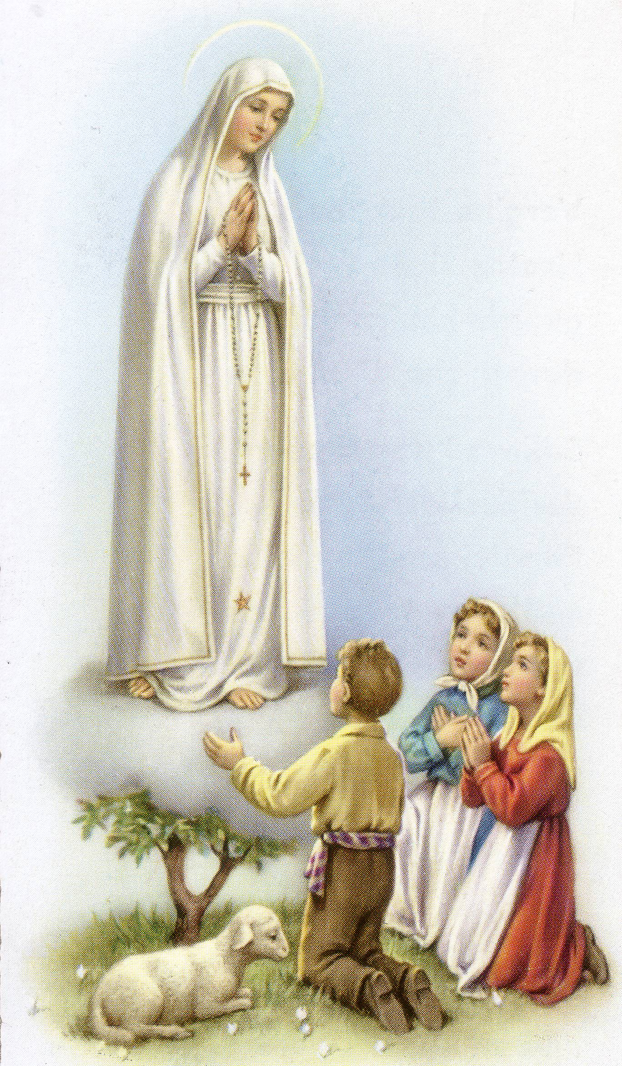
DOMENICA 19 MAGGIO 2013
Nella chiesa di San Giuseppe Lavoratore
79 Wilson Blvd North Reservoir

3.00pm - Santa Messa cantata,
Celebrata da Rev Padre Luciano Toldo,
Padre Emanuele Bonello PP & Fr Joseph Yu PE

Segue processione con la statua e recita del Santo Rosario sui piazzali della chiesa. Fiaccolata con Inni e Preghiere. Ritorno in chiesa per la Benedizione Eucaristica.

La celebrazione sara’ accompagnata dal musicista Raffaele Rossi.

Segue un rinfresco!

Per informazione: Renato – 9460 4597 Gina – 9462 1641 Paola – 9460 7990

BAPTISM
Congratulations to Sienna Alana Ferraina child of Michael & Melinda who will be baptised this weekend. We welcome her into our parish community and assure the family of our prayerful best wishes on this happy occasion.

FUNERAL NOTICE
The Rosary for Luigi Scalora will be recited on Monday 6 May at 10.00am followed by Funeral Mass.

MEMORIAL MASSES
Monday 6 May 7.30pm – Giuseppe Cunto (1mth)
Wednesday 8 May 7.00pm – Francesco Bruno (d. Rec. Italy)

ITALIAN LADIES
Maggio, mese dedicato alla Madonna con la recita del S. Rosario nelle famiglie della parrocchia. Se desiderate la Statua della Madonna potete rivolgervi ai membri del comitato.
Paola: 9460 7990, Maria: 9469 2141, Gina: 9462 1641

RIVER OF LIFE CONFERENCE – FREE SEATING FOR YOUTH GROUPS 10 MAY, 7:10PM
The River of Life Conference is an inter-denominational event taking place in Melbourne during May. Free balcony seating is available for any Youth Group wishing to attend the final evening session on Friday 10 May. The program includes praise singing led by Darlene Zscech and band, preaching by Dr Yonggi Cho, and prayer for the city.
Where: Melbourne Convention and Exhibition Centre, 2 Clarendon St, Melbourne VIC 3006
Cost: Free
More Info: www.riveroflifeconference.org

BISHOP JOSEPH O’CONNELL

As a Parish Community this weekend we join with Archbishop Denis Hart and the Vicar General Mgr. Greg Bennett to pay a special tribute to Bishop Joseph O’Connell who died peacefully on Saturday 27.4.13 at Caritas Christi, Kew.

Bishop Joe O’Connell was born on 10th December 1931, and lived in Thornbury and attended St. Mary’s School, Thornbury and Christian Brothers’ College, East Melbourne. In 1949 Bishop O’Connell commenced studies for teaching, but at the beginning of 1950 he entered Corpus Christi College Werribee to study for the priesthood and was ordained priest by Archbishop Justin Simonds in St Patrick’s Cathedral on 28 July 1957. He served as an assistant priest in West Geelong and shortly after was sent to Rome to study Canon Law, obtaining his doctorate in 1961.

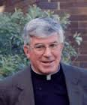
On his return to Melbourne he ministered in the parishes of West Melbourne and Yarraville, together with an appointment to the Archdiocesan Tribunal. In 1969 he was also appointed Episcal Vicar for Religious. On February 12, 1976 Pope Paul VI appointed him as Auxiliary Bishop in Melbourne and was consecrated by Archbishop Frank Little on 31st March 1976. As an Auxiliary Bishop he lived in Moonee Ponds taking pastoral care to the parishes of the Northern Region a position he held for over 30 years until his retirement on December 10, 2006.

To the priests, religious and lay people of the Northern Region, Bishop Joe O’Connell was a kindly shepherd. Bishop Joe’s down to earth manner allowed him to mix easily with all people. Serving for such a long time in the Northern region meant that he knew generations of families and was blessed by a wonderful memory for names.

In particular Bishop Joe had a deep appreciation of the contribution of migrant communities. His years in Rome, gave him an ease with Italian and allowed him to converse with the large Italian population in his region. He understood the needs of those newly arrived on our shores and watched proudly as they took their rightful place in parish leadership and in society.

To his fellow Bishops, priests, religious men and women and the lay people of Melbourne, Bishop O’Connell was a wise advisor, spiritual guide and witness to the Good News. To his many friends Bishop O’Connell will be remembered for his kindness, loyalty and encouragement.
“Good bye, and well done great Bishop, we miss you deeply, Rest in Peace”

Bishop O’Connell’s Funeral will be as follows:

Pontifical Vigil Mass at St. Monica’s Church, Mt. Alexander Road Moonee Ponds on
Thursday 9th May 2013 at 7.00pm
Pontifical Funeral Mass at St. Patrick’s Cathedral, Melbourne on Friday 10th May 2013 at 11.00am.
His burial will take place at 1.30pm in the Priests’ Crypt at the Melbourne General Cemetery, Carlton.

