As we come and worship, we remember the wurundjeri people, the original custodians of this land

FIRST READING Ezekiel 33:7-9
If you have not warned the wicked man, then I will hold you responsible for his death.

RESPONSORIAL PSALM SALMO RESPONSORIALE
O that today you would listen to his voice! Harden not your hearts. | Ascoltate oggi la voce del Signore.
SECOND READING Romans 13:8-10
Love is the fulfilment of the Law.

GOSPEL ACCLAMATION CANTO AL VANGELO
Alleluia, alleluia  God was in Christ, to reconcile the world to himself; and the Good News of reconciliation he has entrusted to us.  Alleluia! | Alleluia, alleluia!  Dio ha riconciliato a se’ il mondo in Cristo, affidando a noi la parola della riconciliazione. Alleluia!
GOSPEL Matthew 18:15-20
If your brother or sister listens to you, you will have won that person back.

THANKS TO THOSE WHO GAVE LAST WEEK
1st Collection - Thanksgiving Offering…………………………..$683.00
- Loose Money…………………………………….$358.00
2nd Collection - Presbytery………………………………………..$325.00

PLEASE NOTE THAT THOSE WHO ARE ROSTERED ON TO READ OR GIVE COMMUNION AT MASS ARE KINDLY ASKED, IF POSSIBLE, TO ARRIVE 10 MINUTES BEFORE MASS STARTS
LECTORS - THIS WEEK 07/09/2014 SPECIAL MINISTERS
6.00pm (SAT) – MALTESE MASS (Selected) MALTESE MASS (Selected)
9.00am (SUN) – L Calafiore & L Catena A Sonza, G Barbaro & M Piscioneri
10.30am (SUN) – J Iaria & S Miano P Nguyen, S Rottura & S Miano

LECTORS – NEXT WEEK 14/09/2014 SPECIAL MINISTERS
6.00pm (SAT) - E Saliba & N Ziino J Pullicino & M Mizzi
9.00am (SUN) – R Mercuri & R DiGuglielmo L Catena, M Crupi & A DiRico
10.30am (SUN) – Sr T Fitzsimmons &E Bartlett C McMahon, D Herbert & A Filippone

MONEY COUNTERS 08 /09/2014 J & J Kearney, E & K Bartlett, C McMahon & S Dakin
15/09/2014 A Sinopoli, F Nardozza, I Manini & R Comito
YOUR PRAYERS ARE REQUESTED FOR THE FOLLOWING
RECENTLY DECEASED
Gino CAFAGNA (d. Rec. Italy) Serafino BRIGANTI, Robert POWER,

ANNIVERSARIES
Giuseppe VIRGONA, Doloris AGIUS, Nicola MATTEO, Gioacchino ARCOLEO, Luigi GIAMMARCO,
Antonio, Loreto & Domenica TARQUINIO, Angelo & Rosa RAULLI, Francesco CONTE,
Francesco TORCASO, Antonio RISOLI, Antonio & Gerardo ALBERTI, Antonio VILLELLA,
Gennaro FALVO, Pasquale, Luigi & Giovanni VILLELLA, Felice BRUNO,
Michaelangelo, Giovanni & Michael BUTERA, Sylvia FERRITO, Giuseppe & Angelina TODARO,
John PASCUZZI, Giuseppe & Antonina CATALANO, Domenico & Domenica VARRENTI,
Vincenzo & Fidalma CIPOLLA, Domenico & Anna OCCHIUZZI, Francesco & Bruno MULTARI,
Domenico ALAGNA, Pietro STRANIERI, Pasquale TIMPANO, Francesco SANTOPIETRO, Anniversaries Cont:

ST JOSEPH THE WORKER
_______________________________________NORTH RESERVOIR _________________________________________

79 Wilson Boulevard, North Reservoir 3073

Parish House/Office Tel: 9460 3013 Fax: 9460 8832 Mb: 0431 643 674
Email: Parish@stjosephtheworker.org.au
www.stjosephtheworker.org.au
School Tel: 9469 7800 Fax: 9462 2949

SUNDAY MASS TIMES: Fr Emmanuel Bonello–Parish Priest WEEKDAY MASS TIMES:

Sat 6.00pm - English Sr Estelita Manabo-Pastoral Associate Mon. 9.10am Comm. Service
Sun. 9.00am - Italian Mr Peter Chowne -School Principal Tue. 10.00am Italian

Sun. 10.30am – English Mrs Liz Pistoni – Parish Secretary Wed. 9.10am - English

Thur. 9.10am - English

Maltese Mass Fri. 9.10am - English Sat. 8.30am - English
1st Saturday of the Month 6.00pm Sat. 8.30am - English Sat. 8.30am-English
Baptisms – Sunday 12.00pm Reconciliation: Sat. 10.30am
Marriages - By Appointment

23rd Sunday, Year A 7 September, 2014
Correct with Care

As his ship sailed through the heavy fog, the captain remained on the bridge and put his crew on high alert. Soon, one of the lookouts reported a light to starboard and the light remained steady. Another ship was coming toward and on a dangerous course that would result in a collision. The captain radioed the other ship to change course. Back came the terse answer “Advise that you change course. This is a lighthouse!” The captain changed course.
Today’s gospel-reading addresses the issue of what to do about a member of the Christian community who has sinned seriously but refuses to amend and remains recalcitrant. It tells us to be like the lighthouse keeper and advise a change of course to avoid going aground on the rocks of error.
The gospel further advises that we need to exercise this responsibility with sensitivity. Don’t blaze away with both barrels of reproof. Don’t pass the buck, instead, take courage, speak personally, one-to-one with the offending member and help him or her to see the error of their ways. Be ready to exercise liberal forgiveness. If this fails, go with two or three reliable and mature Christians who may persuade a change of heart. If this second attempt is unsuccessful, that person is to be excluded from the Christian community i.e. excommunicated.
Communion in faith and morals is the deepest vocation of God’s people – the Church. We are one family under God and those bonds of communion are not to be compromised or diluted. Excommunication from this community is a drastic step and not to be undertaken lightly. Perhaps, in the past, we have been too eager to excommunicate people. Over time the people of God have learned to be more open, tolerant and forgiving. These are welcome developments.
However, it is also true that, as Church, we have lost some of the appetite to confront our wayward and obstinate members. Perhaps we have overvalued individuality and neglected to properly appreciate the vital role community occupies in Christ’s vision for his Church.
We must, of course, continue to value the individual person and respect that person’s rights and choices. But it is plainly wrongheaded to condone and meekly accept opinions and life-choices that contradict Jesus’ teachings and bring disrespect and harm to the unity and peace of God’s people.
The gospel advises us to take courage and to confront and challenge the intransigent members of our Christian community. It insists that we confront them but in a sensitive manner that demonstrates both our love and care for the offending person, and our love and care for the Christian community.
We must not step back from our Christian duty to be a ‘lighthouse’ to steer our misguided Christian brothers and sisters from the rocks of error.


Father’s Day Appeal
for the Sick and Retired Priests of Melbourne

The special collection for the Sick and Retired Priests of Melbourne will be held this weekend 6th & 7th September. Priests generally retire at 75 years according to Canon (Church) Law. Melbourne has 87 priests currently retired, they have ministered in most Melbourne Parishes. Out of these 87 retired priests, 1retired priest is aged 100, 3 are in their nineties, 50 retired priests are aged in their 80s, 17 are aged between 75-80, 13 between 66-75 and also 3 priests aged under 65 who have retired due to ill health. The Retirement Foundation meets their needs. Retired Priests have served us well. Most have served 50 years in parish ministry before retiring (at age 75). They are grateful for your support now and in the future. There are 13 priests over 75 and 65 priest aged 65-75 who are still working in Melbourne Parishes – they will soon need our support. There will be an average of 6 retirements each year for the next six years. Donations of $2 or more are tax deductible. Receipts are issued by mid-July for gifts of $5 or more. Please give generously.

BAPTISIM PREPARATION
The Baptism Preparation Meeting will be held on Monday 8 September at 7.30pm in the Parish Meeting Room.

FEASTS
Monday 9 September – The Nativity of the Blessed Virgin Mary
Saturday 13 September – St John Chrysostom

FUNERAL
Rosary for Serafino Briganti will be recited on Monday 8 September at 7.00pm. Funeral Mass will be celebrated on Tuesday 9 September at 1.00pm.

MEMORIAL MASSES
Tuesday 9 September 10.00am – Vincenzo Giovinazzo (1yr)
Friday 12 September 7.30pm – Sebastiana Renda (1mth)
Saturday 13 September 6.00pm – Angela Salera (1 yr)


CUPPA
There will be a Cuppa in the Narthex after the 10.30am Mass next weekend. Please stop and enjoy the hospitality of the parish and meet some fellow parishioners.

FEAST OF MARIA BAMBINA
Reskeon Maltese Association and Reskeon Seniors Group, on behalf of the Missionary Society of St Paul, are organising the Feast of Marija Bambina. On Monday, Sept. 8, Mass at St Paul’s Chapel, Ievers St., Parkville (near the Maltese Centre), 7 pm. On Sunday, Sept. 14, the Feast at St Mary Star of the Sea Church, Howard St, West Melbourne. 2.30 pm Rosary, followed by Mass and Procession with the Statue accompanied by the Maltese Own Band. On Saturday, Sept. 6, the Bambina Dinner Dance, Firenze Receptions, McBryde St, Fawkner, 5 course meal, $50 a head. The Maltese Community and others are invited to attend. Phone 9460-4404 Mobile 0409 961 928.

THE JOY OF THE GOSPEL TUESDAY 16 SEPTEMBER, 7.30PM
St Andrew’s Parish, Penola Community Hub, 33 Mortimer Street, Werribee
Fr. Elio Capra will explore Pope Francis’ book The Joy of the Gospel, as the Pope is calling us to become a compassionate, welcoming and missionary Church. Light refreshments provided.
Contact: Werribee@cam.org.au

SOLENNE CELEBRAZIONE ALLA VERGINE DEL S. ROSARIO
Domenica 5 Ottobre 2014
nella nostra parrocchia di San Giuseppe Lavoratore.
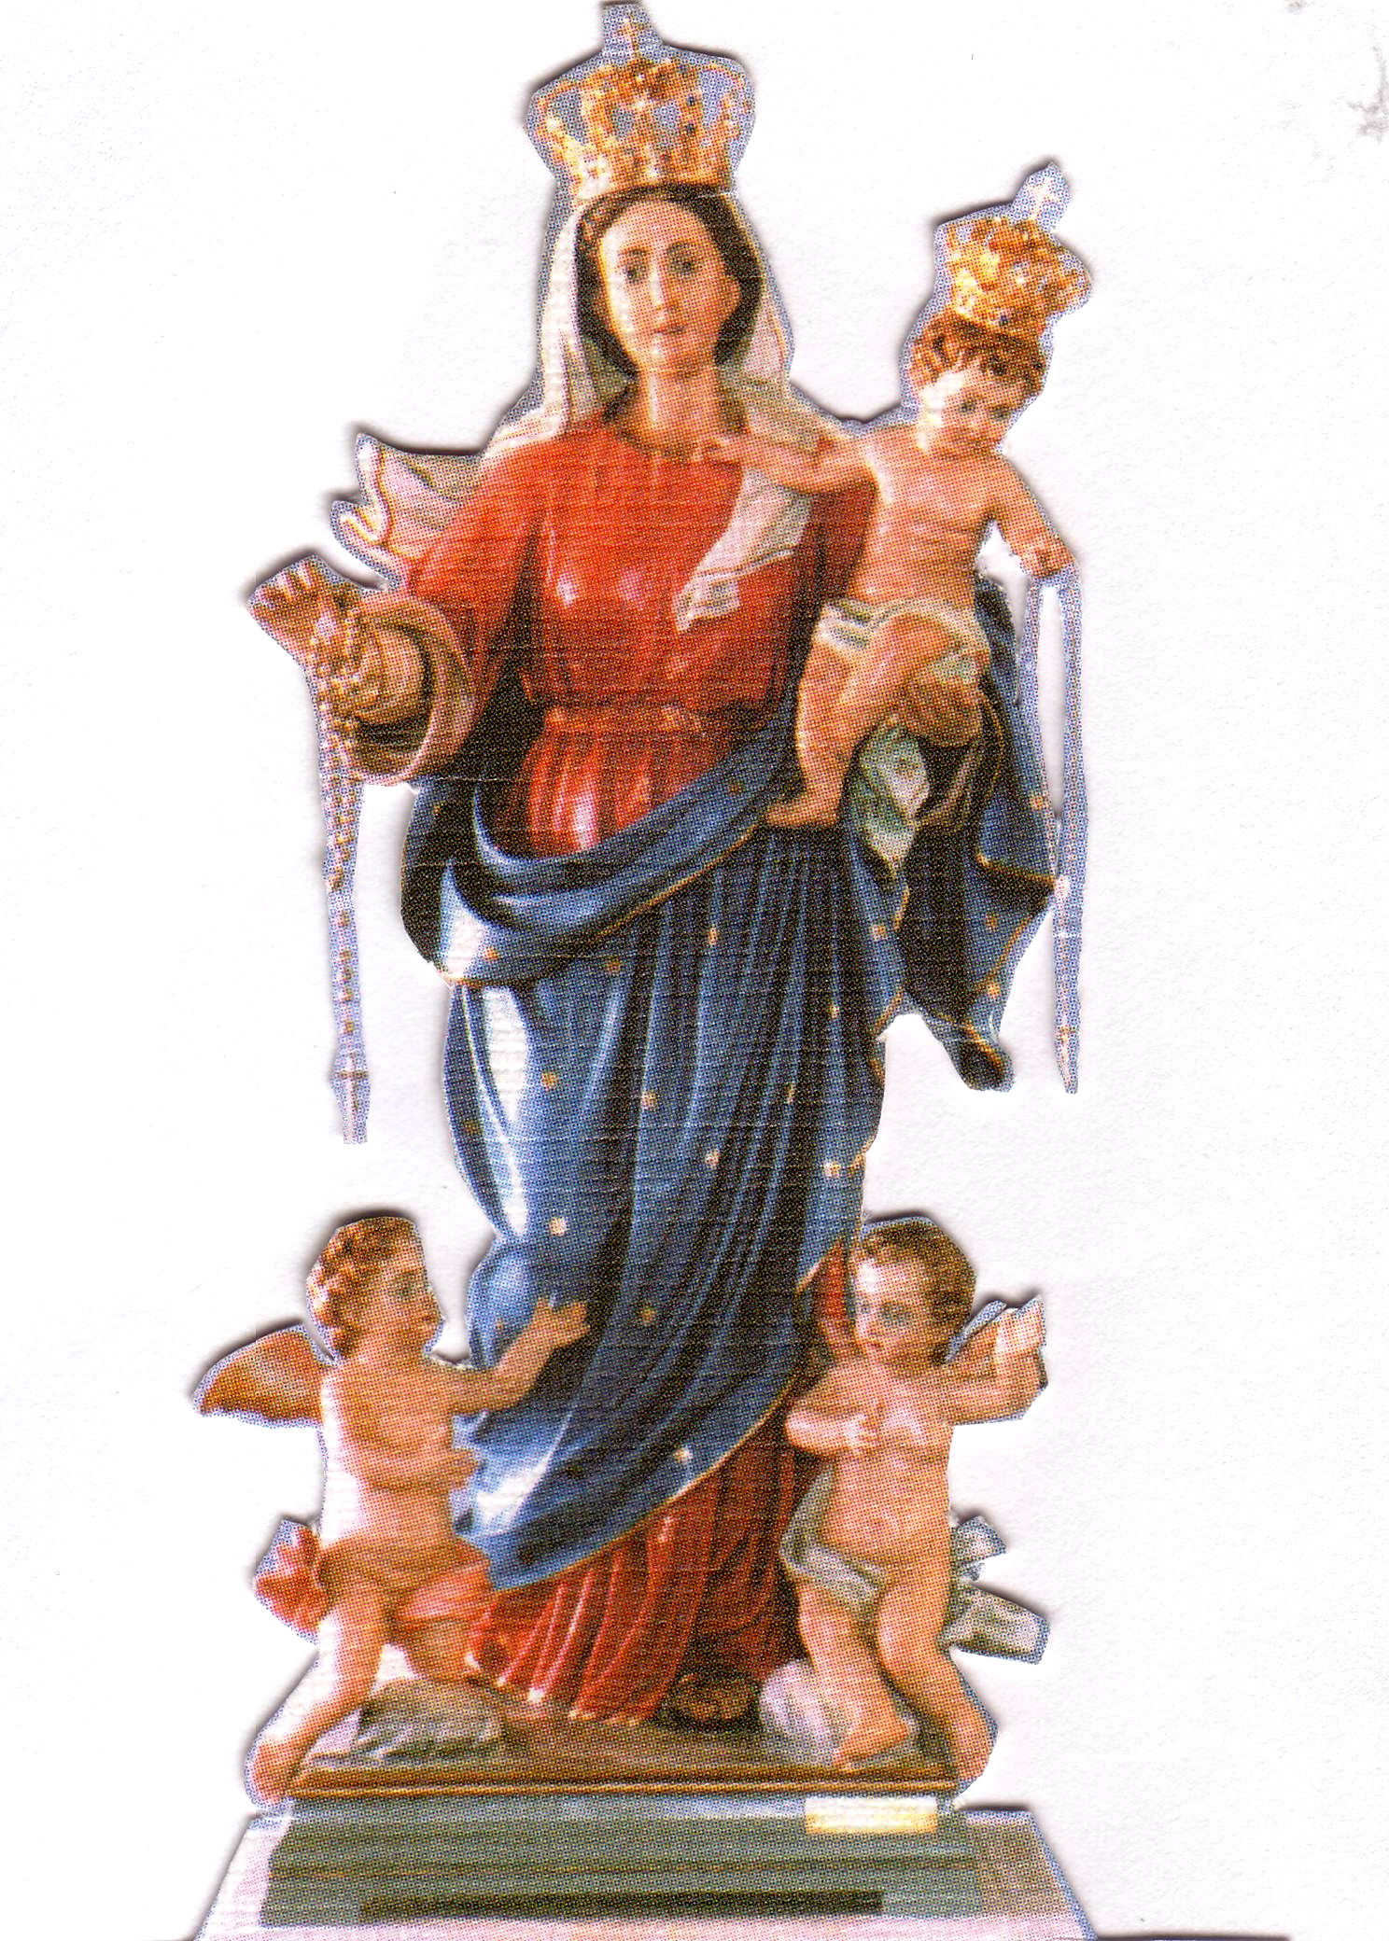
PROGRAMMA

ORE 2.00PM
Preghiere e Inni.
Processione con la statua
Recita del S. Rosario con i Misteri presentati dai bambini.

ORE 3.00PM
Santa Messa
concelebrata con Padre Delamar Silva, Padre Emanuele Bonello e Padre Giuseppe Yu.

Preghiera di affidamento alla Madonna.
Benedizione con il S.S.. Sacramento ai malati e famiglie.

FOUNDATIONS IN CATHOLIC SOCIAL TEACHING – FOR YOUTH AND YOUNG ADULTS
Mondays, 8, 15, 22 and 29 September, 6.30pm–8pm
Cardinal Knox Centre, corner of Lansdowne and Albert Streets, East Melbourne
What do buying clothes, volunteering and mining have in common? All of our choices – from the brands we buy, the charities we support, the places we visit, to the companies we work for – affect other people. Pope Francis has said that our consciences ‘need to be converted to justice, equality, simplicity and sharing’ (Message for Lent 2014) but what does this mean for us? Wouldn’t it be nice to have a road map to help us make some of these decisions? The Church’s social teachings can be that map! Catholic social teaching helps us interpret the Gospel message in a practical and contemporary context. (Optional dinner afterwards at the Imperial Hotel- kitchen open till 9pm.)
Contact: The Archdiocesan Office for Youth at aoy@cam.org.au or on 9287 5565

UNIQUE CLINICAL PASTORAL EDUCATION OPPORTUNITY: CPE RESIDENCY PROGRAMME 2015
The Peter MacCallum Cancer Centre is Australia’s only public hospital solely dedicated to cancer and one of an elite group of hospitals worldwide to have its own integrated cancer research program and laboratories. Four opportunities are available for people with a passion for Pastoral Care. This is a nine-month full-time education programme, commencing 16 February 2015 and concluding October 30, 2015. The personal attributes required are spiritual maturity, openness, an ability to take initiative and to work within a multidisciplinary team and a commitment to your ongoing development. Applications close Friday 10 October. Contact: paula.donnoli@petermac.org or 9656 1301

Anniversaries Cont: Domenico PICCONE, Antonio DIGUGLIELMO, Giuseppe FATO, Pietro COSTANZO,
Luigi PASCUZZI, Antonio, Lunella, & Ines CALIGIURI, Pasquale, Angela & Mario LUNA, Famiglia VALMORBIDA,
Famiglia CAVEDON, Francesco PARLATI, Vito & Giuseppe DEL ZOTTI, Angelo MACCIOCCA, Ercole DI RICO,
Felice, Antonio & Maria CARUSO, Saverio & Rosa NICOLAZZO, Carmelo & Santo RENNA,
Francesca & Giuseppe MOTTA, Vita & Vincenzo MONITTO, Giuseppina, Pippo & Vincenzo BELLOMO,
Corrado PELLIGRA, Rocco & Francesco FERRARO, Sagvincezo & Antonio PUGLIESE, Vincenzo CRUPI,
Francesco BARRESE, Antonio & Beniamino PASCUZZI, Matteo NAPOLITANO, Luigi, Frank & Angelo SPARANO,
Michele & Antonio ROSSIGNUOLO, Giovanni PAPALIA, Vincenzo & Giovanni CALVI, Saverio COLOSIMO,
Natale FATO, Janez & Matteo ZELE, Antonio GRAHOR

