As we come and worship, we remember the wurundjeri people, the original custodians of this land

FIRST READING Wisdom 7:7-11
In comparison to wisdom, I held riches as nothing.

RESPONSORIAL PSALM SALMO RESPONSORIALE
Fill us with your love, O Lord,  and we will sing for Joy! | Saziaci, Signore, con il tuo amore: gioiremo per sempre.
SECOND READING Hebrews 4:12-13
The word of God discerns the thoughts and intentions of the heart.

GOSPEL ACCLAMATION CANTO AL VANGELO
Alleluia, Alleluia!  Happy the poor in spirit;  the kingdom of heaven is theirs!. Alleluia! | Alleluia Alleluia,  Beati i poveri in spirito, perche’ di essi e’ il regno dei cieli. Alleluia.
GOSPEL Mark 10:17-30
Go and sell whatever you have and come follow me.

THANKS TO THOSE WHO GAVE LAST WEEK
1st Collection - Thanksgiving Offering…………………………..$502.00
- Loose Money…………………………………….$318.00
2nd Collection - Presbytery………………………………………..$326.00

PLEASE NOTE THAT THOSE WHO ARE ROSTERED ON TO READ OR GIVE COMMUNION AT MASS ARE KINDLY ASKED, IF POSSIBLE, TO ARRIVE 10 MINUTES BEFORE MASS STARTS
LECTORS - THIS WEEK 11/10/2015 SPECIAL MINISTERS
6.00pm (SAT) – N Ziino & D Pullicino T Nguyen & E Krygger
9.00am (SUN) – R Pino & L Cavedon F Pascuzzi, G Tempone & C Alberti
10.30am (SUN) – E Thompson & L Conte A Gatto, J Iaria, J Kearney, D Herbert
R Rottura

LECTORS – NEXT WEEK 18/10/2015 SPECIAL MINISTERS
6.00pm (SAT) E Krygger & E Saliba S Dakin & N Ziino
9.00am (SUN) – T Forte & R DiGuglielmo R Pino, S. Lobartolo & R DeZan
10.30am (SUN) – L & L De Marco C McMahon, P Nguyen, V De Leo
E Bartlett & M Mizzi
MONEY COUNTERS 12/10/2015 J & J Kearney, E Bartlett, C McMahon & S Dakin
19/10/2015 A Sinopoli, F Nardozza, I Manini & R Comito
YOUR PRAYERS ARE REQUESTED FOR THE FOLLOWING
RECENTLY DECEASED
Vincenzo GUARINI, Iginio CAPALDO, Grazia CORRONE (d.rec. Italy), Josephine COLEIRO,
Antonio BASILE, Maria FORTE, Maria BEGA

ANNIVERSARIES
Oreste & Libera SEGAT, Cristina PASCUZZI & Angela SALERA, Giovanni CALVI,
Bartolo “Bob” PALAMARA, Concetta GUARINI, Salvatore & Sofia RACHIELE, Sandro FILIPPONE
Antonio & Filomena PISANI, Caterina MERCURI, Domenico LEONELLO, Giovanna CANNIZZARO

ST JOSEPH THE WORKER
_______________________________________NORTH RESERVOIR _________________________________________

79 Wilson Boulevard, North Reservoir 3073

Parish House/Office Tel: 9460 3013 Fax: 9460 8832
Email: Parish@stjosephtheworker.org.au
www.stjosephtheworker.org.au
School Tel: 9469 7800 Fax: 9462 2949

SUNDAY MASS TIMES: Fr Emmanuel Bonello–Parish Priest WEEKDAY MASS TIMES:

Mb: 0431 643 674

Sat 6.00pm - English Sr Estelita Manabo-Pastoral Associate Mon. 9.10am Comm. Service
Sun. 9.00am - Italian Ms Marisa Steele -Acting School Principal Tue. 10.00am Italian

Sun. 10.30am – English Mrs Liz Pistoni – Parish Secretary Wed. 9.10am - English

Thur. 9.10am - English

Maltese Mass Fri. 9.10am - English Sat. 8.30am - English
1st Saturday of the Month 6.00pm Sat. 8.30am - English Sat. 8.30am-English
Baptisms – Sunday 12.00pm Reconciliation: Sat. 10.30am
Marriages - By Appointment

28th Sunday, Year B 11 October 2015
Happy Ever After

Fairy tales always have happy endings; at least for those who have been good and kind. The one-time persecuted and demeaned Cinderella wins the hand of a prince but her persecutors, the ugly step-sisters are ignored. Jack gets the goose that lays the golden eggs, while the greedy giant falls to his death when Jack cuts down the bean stalk.
From our younger years we have been conditioned, often by the telling of stories like these fairy tales, to expect reward and success as payment for being blameless and virtuous. Our instinctive sense of justice demands recompense for righteousness and, of course, punishment for immortality. Today’s gospel, however, confounds such expectations and suggests that the quest for eternal life cannot be reduced to simple equation: keep the commandments and inherit eternal life; break the commandments and reap eternal damnation. Both the wealthy man and Jesus’ own disciples in today’s gospel believe their observance of the law or their sacrifices for the mission will save them. But Jesus is quick to disavow them of their expectations. The wealthy man is asked to detach himself from his “many possessions” (Mk 10:22) and the disciples are reminded that their rewards will only come with “persecutions” (Mk 10:30). What we have in this story is an example of Jesus’ radical reinterpretation of God’s commandments. Similar examples can be found in the so-called “sermon on the mount” (Mt 5:1-7:29), where Jesus proclaims that the truly “righteous” person will not just refuse to commit murder, but disdain anger (Mt 5:21-26); will not just avoid adultery, but eschew lust (Mt 5:27-28). One can conceivably live one’s life according to the “letter of the law”, as claimed by the wealthy man in the gospel (Mk 10:20). Being blameless and virtuous, however, may not be enough! This story does not have a happy ending. The man “went away sad” (Mk 10:22), because he was unable to commit himself and all his possessions to Jesus’ cause. Like a character in a fairy tale, the wealthy man came seeking the secret formula that would enable him to “earn the birthright” to eternal life (Mk 10:17). He saw salvation as a commodity that could be won by being good. But Jesus is no fairy godmother and eternal life is not a golden egg laid by a magical goose. Salvation comes as a free gift from God to all, blameless and blameworthy alike (Mk 10:27); it cannot be earned. As Jesus reminds the wealthy man, “No one is good but God alone” (Mk 10:18). There is no secret formula or simple equation for doing good that will win one’s salvation. We can only attain eternal life by accepting God’s gift, wholeheartedly and unreservedly; committing everything we are and everything we have to the life and vocation to which God has called us.

CUPPA

This weekend after the 10.30am Mass there will be a cuppa in the Narthex. Please stop and
enjoy the hospitality of the parish.

BAPTISM PREPARATION
The Baptism Preparation Meeting will be held on Monday 19 October at 7.30pm in the Parish Meeting Room.

FUNERALS
Rosary for Iginio Capaldo will be recited on Tuesday 13 October at 12.00pm followed by Funeral Mass.

Rosary for Maria Forte will be recited on Tuesday 13 October at 7.30pm. Funeral Mass will be celebrated on Wednesday 14 October at 10.30am.

Funeral Mass for Maria Bega will be celebrated on Friday 16 October at 10.30am.

LITURGY TEAM MEETING
The Liturgy Team Meeting will be held on Tuesday 13 October at 7.30pm in the Presbytery

FEASTS
Thursday 15 October – St Teresa of Jesus
Saturday 17 October – St Ignatius of Antioch

RINGRAZIAMENTI
Domenica 4 Ottobre, festa della Madonna del S. Rosario. Una grande folla ha onorato con canti e preghiere la Madre celeste. Un sincero grazie a Monsignor Carmelo Refalo per averci condotto in preghiera e per averci parlato di questa dolce Madre che cammina con noi e ascolta le nostre suppliche. Grazie a Padre Bonello, concelebrante della bellissima celebrazione. Molti i bambini che si sono consacrati alla protezione di Maria. Grazie a tutte le mamme e nonne, ai membri del comitato e a coloro che hanno contribuito con donazioni e il rinfresco.

RESPECT LIFE SUNDAY 11TH OCOBER 2015
The theme for this year’s Respect Life Sunday is “Be Not Afraid” The gift of Palliative care. We offer our thoughts and prayers for the sick and terminally especially those in our parish community that they find comfort and hope in God’s mercy and those who care for them continue bearing witness to the reality that the human person is always precious, even if marked by age and sickness. For more inofrmation on video and other material about Respect Life Sunday look on the Life, Marriage and Family Office website: www.cam.org.au/lifemarriagefamily
MARIAN MISSION DAY: OUR LADY OF TEARS Saturday 17 October, 6.30pm and Sunday 18 October, 2.30pm
Saturday: Vizzini Social Club, 322 Sydney Road, Coburg & Sunday: St Brendan’s, 103 Wellington Street, Flemington
The Committee of Our Lady of Tears, Melbourne, invites you to the 2015 Marian mission: the consecration of the family to Mary. Led by Monsignor Franco Cavarra, this will be a double celebration. A gala dinner with orchestra on the Saturday night in Coburg will be followed the next day by a multicultural Mass at St Brendan’s in Flemington, starting at 2.30pm with rosary and confession, followed at 3pm by solemn Mass. All welcome.
Cost: $50 (dinner Saturday night)
Details: Paolo on 9302 2326 or Maria on 0425 855 594 or Tina on 9460 2682

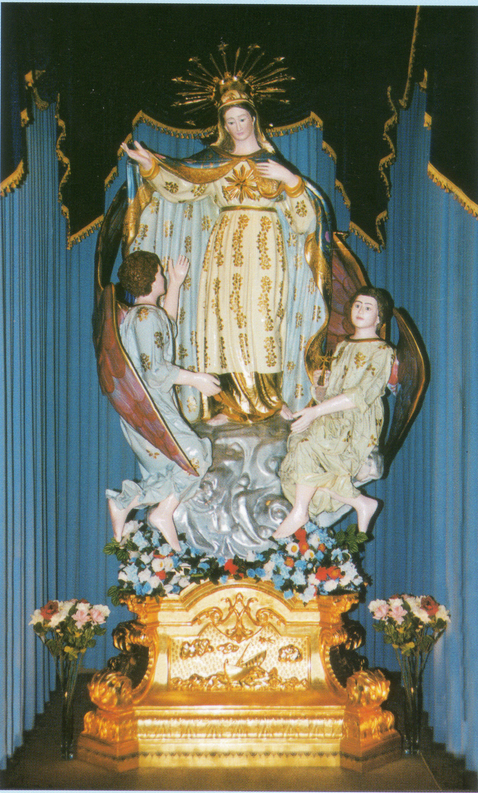
FEAST OF STELLA MARIS

FRIDAY 16 OCTOBER:
6.30pm: Confessions in English and Maltese will be heard at St. Joseph the Worker Church.
7.00pm: Mass celebrated by Rev. Fr. De Giorgio
There will be presentation of flowers to Our Lady.
After Mass everyone is invited to join us for some refreshments.

SATURDAY 17 OCTOBER:
6.30pm: Feast dinner Dance will be held at Emerald Receptions. DJ Domenic will be entertaining us on the night. Later on in the night the Maltese United Brass Band will join us to entertain us playing various joyous marches.

SUNDAY 18 OCTOBER:
2.30pm: High Mass starts. It will be celebrated by the Parish Priest, Cannon Manuel Bonello, assisted by Rev. Denis Carabott MSSP and Rev. De Giorgio. The Maltese Choir of Victoria, will participate during Mass. All Associations are invited to take part by joining us in the church celebrations as well as during the procession carrying their banners.
4.00pm: The procession with the beautiful Statue of Stella Maris will commence. The Maltese Own Band will accompany the Statue around the streets of the Church.

6.00pm: After the procession everyone is welcome to come in the Hall where the two Maltese Bands will perform. Afterwards there will be DJ Domenic to entertain us.

THERE WILL BE FOOD AND DRINK FOR SALE. EVERYONE IS WELCOME.
THE COMMITTEE WISHES EVERYONE A GOOD TIME DURING THE FESTIVITIES.

EXTRAORDINARY JUBILEE YEAR OF MERCY “TASTE AND SEE”

Pope Francis has invited us all to embark on a Jubilee Year to deepen our understanding of mercy as a church and society. The Year begins on December 8th and will go until 20th November 2016. The Archbishop Office for Evangelisation will hold a workshop day introducing the Year of Mercy. This will be a Year of Mercy planning day to be held on Saturday 17th October 2015 from 10am – 3pm at the Catholic Leadership Centre in East Melbourne. Cnr. Hoddle St and Victoria Pde. (It’s easily accessible by public transport and there’s street parking nearby.) The day includes a keynote presentation by international guest Margaret Silf, author and spiritual director from the UK, followed by workshops unpacking the themes of the Year. There will also be a showcase of resources to help parishes think about how they can participate. This workshop day is useful to priests, pastoral associates, members of Pastoral and Liturgy team.
Any parishioner is welcome to attend. Please let Fr. Manny know if you wish to attend. Fr. Manny will be attending. This day will help us as a parish to participate and acknowledge the Year of Mercy next year.

