As we come and worship, we remember the wurundjeri people, the original custodians of this land

FIRST READING Matthew 21:1-11 - Blessed is he who comes in the name of the Lord.
Isaiah 50:4-7 - I did not cover my face against insult and I know I will not be ashamed.

RESPONSORIAL PSALM SALMO RESPONSORIALE
My God, my God, why have you abandoned me? | Mio Dio, mio Dio,perche’ mi hai abbandonato?
SECOND READING Philippians 2:6-11
He humbled himself to become like us and God raised him on high.

GOSPEL ACCLAMATION CANTO AL VANGELO
Praise to you, Lord Jesus Christ, king of endless glory!  Christ became obedient for us even to death, dying on the cross.  Therefore God raised him on high and gave him a name above all other names.  Praise to you, Lord Jesus Christ, king of endless glory! | Lode e onore a te, Signore Gesu’!  Per noi Cristo si e’ fatto obbediente fino alla morte, e a una morte di croce. Per questo Dio lo esalto’ e gli dono il nome che e’ al di sopra di ogni nome.  Lode e onore a te, Signore Gesu’!
GOSPEL Matthew 26:14-27:66
Passion of our Lord Jesus Christ according to Matthew.

THANKS TO THOSE WHO GAVE LAST WEEK
1st Collection - Thanksgiving Offering…………………………..$484.00
- Loose Money…………………………………….$489.00
2nd Collection - Presbytery………………………………………..$431.00

PLEASE NOTE THAT THOSE WHO ARE ROSTERED ON TO READ OR GIVE COMMUNION AT MASS ARE KINDLY ASKED, IF POSSIBLE, TO ARRIVE 10 MINUTES BEFORE MASS STARTS
LECTORS - THIS WEEK 09/04/2017 SPECIAL MINISTERS
6.00pm (SAT) – Evelyn Krygger & D Pullicino Sylvia Dakin & E Saliba
9.00am (SUN) – L Cavedon & R Fato P Sparano, R Pino, L Cavedon & F Multari
10.30am (SUN) – L De Marco & R Covello J Iaria, B Calrk-Loh, E Bartlett & T Nguyen

LECTORS – NEXT WEEK 16/04/2017 SPECIAL MINISTERS
6.00pm (SAT) Easter Vigil (Selected) Easter Vigil (Selected)
9.00am (SUN) – C Agostinelli & R Pino D Biasibetti, S Lobartolo, P Leggiero & L Calafiore
10.30am (SUN) – Easter Sunday (Selected) Easter Sunday (Selected)
MONEY COUNTERS 10/04/2017 J Kearney, E Bartlett & S Daikin
17/04/2017 A Sinopoli, F Nardozza, I Manini & R Comito

YOUR PRAYERS ARE REQUESTED FOR THE FOLLOWING RECENTLY DECEASED
Mariano “Mario” TRAGLIA, Franca GARGARO, Giovanna CINQUE, Concetta STELLA,
ANNIVERSARIES
Michael BUTERA, Archbishop Frank LITTLE, Bishop Ron MULKEARNS
Joseph DEBONO, Charlie AGIUS, Nazzareno GRECH, Stephen & Emmanuel BORG,
Polly, John & Emmanuel FARRUGIA GAY, Francesco SIRIANNI, Francesco VACIRCA,
Famiglia CAVEDON, Famiglia VALMORBIDA, Famiglia FERRARO, Famiglia PUGLIESE,
Gina DI DONATO, Pasquale & Giuseppina TIMPANO, Grazia MURDICA, Domenico MAMMONE,
Pasquale CAMPISI, Francesco & Antonio SANTOPIETRO
ST JOSEPH THE WORKER
_______________________________________NORTH RESERVOIR _________________________________________

79 Wilson Boulevard, North Reservoir 3073

Parish House/Office Tel: 9460 3013 Fax: 9460 8832
Email: Parish@stjosephtheworker.org.au
www.stjosephtheworker.org.au
School Tel: 9469 7800 Fax: 9462 2949

SUNDAY MASS TIMES: Fr Emmanuel Bonello–Parish Priest WEEKDAY MASS TIMES:

Mb: 0431 643 674

Sat 6.00pm - English Sr Estelita Manabo-Pastoral Associate Mon. 9.10am Comm. Service
Sun. 9.00am - Italian Mrs Maria Barnes -School Principal Tue. 10.00am Italian

Sun. 10.30am – English Mrs Liz Pistoni – Parish Secretary Wed. 9.10am - English

Thur. 9.10am - English

Maltese Mass Fri. 9.10am - English Sat. 8.30am - English
1st Saturday of the Month 6.00pm Sat. 8.30am - English Sat. 8.30am-English
Baptisms – Sunday 12.00pm Reconciliation: Sat. 10.30am
Marriages - By Appointment

Palm Sunday of Lent, Year A 9 April 2017
People are what?

There is a farmer in the US state of Kentucky who every year plows the side of a hill with a single horse. His name is Wendell Berry. When he is not farming, Mr Berry is writing. One essay of his has a strange title: What Are People For? Have you ever heard anyone ask that? I hadn’t. It is clearly a big question. And once you think about it, you recognise that it is so big in fact that it can only be asked and answered in the deepest context.
That context is what we call religion - the realm of faith, of ultimate things - where all that we are and may be, is brought out into the open and made the central issue. But hold on: the way this ultimate question is posed is particularly strange. No one says that. Usually people say ‘What is the purpose of life?’ or ‘Why do I exist?’ or ‘What is the point of it all?’ But Mr Berry posed the question differently: ‘What are people for?’ This is like saying, ‘What is God for?’ or ‘What are children for?’ or ‘What are old people for?’
A famous philosopher once made a very influential rule. He said people should not be used as ‘means’ but only as ‘ends’. He meant that we can’t think about people in the same way that we think about tools, which are properly thought about as ‘means’: I use a fork to eat, or a hammer to build or repair, and I use the iPhone in my pocket to communicate with the friend I want to meet for lunch. But if I use a person, say to satisfy my own ambitions or interests, I am clearly doing something wrong. That is what the philosopher meant, and that is what Mr Berry wants us to wrestle with by stating an ultimate question the way he did.
So it’s Palm Sunday. Imagine you were a disciple standing in the crowd when Jesus entered Jerusalem on the donkey. What is Jesus for? You know: he is the Messiah, the Anointed, who will destroy Israel’s enemies with swift and terrible justice and establish the universal reign of God over all the earth. ‘Hosanna in the highest!’
Now, imagine you are standing at a distance, down the hill from the cross, looking at Jesus’s crucified, lifeless body. Your hopes are completely dashed. Another pretender; another massive failure. You thought this time it was for real. What was Jesus for? Your question has a different tone, and it is one of bewilderment and maybe despair.
You had completely tied up the question of your life with the answer of Jesus. What was that for? But even when the questions themselves no longer makes any sense, hold fast: Easter is the answer to the greatest human questions, however strangely posed.


PROJECT COMPASSION 2017
Like many of her neighbours in her coastal village in the Philippines, Aloma feared for her family’s safety as extreme weather battered their home and environment. But her participation in the Caritas supported integrated Community Development Program has offered her a leading role in helping her vulnerable community prepare for extreme weather events and work together to protect their environment.
Please donate to Project Compassion 2017 and help vulnerable communities in the Philippines learn how to work together to care for their common home, creating a more secure environment and a more secure future for their children.
Please pick up a project compassion box available in the Narthex and near the Church side Door. Thank you.

BAPTISMS
Congratulations to Mila Finco child of Scott and Laura, and Roland Fish child of Liam and Sarah, who will be baptised this weekend. We welcome them into our parish community and assure the families of our prayerful best wishes on this happy occasion.

FUNERALS
Rosary for Franca Gargaro will be recited on Monday 10 April at 10.30am followed by Funeral Mass.

Funeral Mass for Giovanna Cinque will be celebrated on Wednesday 12 April at 10.30am.

EASTER ENVELOPES
Easter envelopes are available for the support of your priests during this Easter season.

PROJECT COMPASSION BOXES
Please return Project Compassion boxes to the sacristy or parish office. Remember to fill-in the inside flap for tax deduction purposes. Many thanks for your generosity.

GOOD FRIDAY COLLECTION
The annual collection for the support of the church in the Holy Land takes place on Good Friday.
This collection promotes the missionary work of the Church in the Holy Land by providing welfare assistance to local Christians in areas such as health, education, employment and housing. Parishes, schools, orphanages and medical centres throughout the Holy Land rely very much on assistance from the Good Friday collection. Your generosity is greatly appreciated.

VOCATIONS NEWS
At the current time, the Archdiocese of Melbourne has thirty-five students for the priesthood. Three of these men are studying in Rome and the rest are studying at Corpus Christi College, our seminary in Carlton. Please pray for these men and for more vocations to the priesthood four our local Church. Each one of us has a role to play in encouraging and praying for vocations from our parishes. When was the last time you prayed for vocations?

Holy Week and Easter Time Table 2017

SUNDAY 9TH APRIL PALM SUNDAY:
Blessing of Palms or other branches during each Mass of that Weekend.

TUESDAY 11TH APRIL:
11.00am Chrism Mass (Mass of the Holy Oils) at St. Patrick’s Cathedral, celebrated by the Archbishop and the priests of Melbourne. Everyone is welcome to attend.

TUESDAY 11TH APRIL:
7.30pm Communal Celebration of Reconciliation.

THURSDAY 13TH APRIL: HOLY THURSDAY:
8.00pm. Mass of the Lord’s Supper followed by the transfer of the Blessed Sacrament to the altar of reposition which will be set up in the chapel.

FRIDAY 14TH APRIL: GOOD FRIDAY
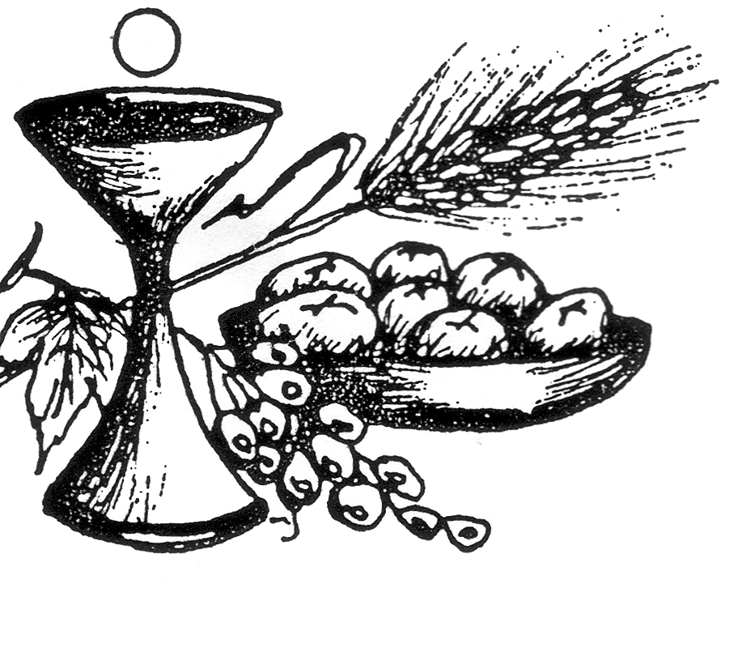

3.00pm Good Friday Ceremonies: Celebration of the Lord’s Passion
7.00pm Via Crucis (Station of the Cross) in Italian & English
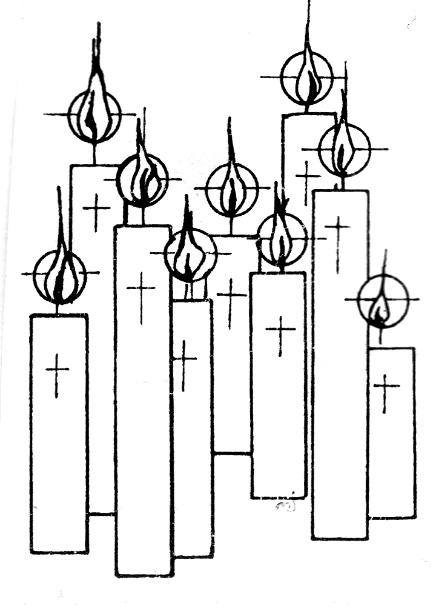
SATURDAY 15TH APRIL: HOLY SATURDAY:
7.00pm Easter Vigil Celebration of Mass

SUNDAY 16TH APRIL: EASTER SUNDAY
9.00am Mass in Italian, 10.30am Mass in English.

MONDAY 17TH APRIL: EASTER MONDAY (PUBLIC HOLIDAY)
There will not be any communion service celebrated. The Church will remain closed.

INDIVIDUAL CONFESSIONS (CONFESSIONI INDIVIDUALI)

Tuesday 11th April: 9.30am
Wednesday 12th April: 10.30am
Thursday 13th April: 10.30am & 7.30pm
Friday 14th April: 10.30am & 2.30pm
Saturday 15th April: 10.30am & 6.30pm

MORELAND PARISH CELEBRATES 90 YEARS
Saturday 22 April, 7pm St Fidelis Parish Hall 49 Clarendon Street, Moreland To celebrate the 90th anniversary of St Fidelis Parish, Moreland, and in conjunction with the jubilee of Catholic Charismatic Renewal, the parish music ministry team presents a praise and worship event 'One Heart One Voice'. Come along for a very special night of music and prayer, gathering as community in the presence of God's love. Details: Ezra May at gracelightsmusic@gmail.com

