As we come and worship, we remember the wurundjeri people, the original custodians of this land

FIRST READING Exodus 34:4-6, 8-9
The Lord God, ruler of all, merciful and loving.

RESPONSORIAL PSALM SALMO RESPONSORIALE
Glory and praise for ever!. | A te la lode e la gloria nei secoli.
SECOND READING Corinthians 13:11-13
The grace of our Lord Jesus Christ and the love of God and the fellowship of the Holy Spirit be with you all.

GOSPEL ACCLAMATION CANTO AL VANGELO
Alleluia, alleluia!  Glory to the Father, the Son, and the Holy Spirit; to God who is, who was, and who is to come. Alleluia! | Alleluia, alleluia.  Gloria al Padre e al Figlio e allo Spirito Santo, a Dio, che e’ che era e che viene. Alleluia.
GOSPEL John 3:16-18
God sent his Son to save the world through him.

THANKS TO THOSE WHO GAVE LAST WEEK
^{st} Collection - Thanksgiving Offering…………………………..$387.00
- Loose Money…………………………………….$350.00
2nd Collection - Presbytery………………………………………..$350.00

PLEASE NOTE THAT THOSE WHO ARE ROSTERED ON TO READ OR GIVE COMMUNION AT MASS ARE KINDLY ASKED, IF POSSIBLE, TO ARRIVE 10 MINUTES BEFORE MASS STARTS

LECTORS - THIS WEEK 04/06/2023 SPECIAL MINISTERS
5.30pm (SAT) – MALTESE MASS (Selected) MALTESE MASS (Selected)
9.00am (SUN) – G Calvi & L Calafiore M Piscioneri, R Pino & R Alberti
10.30am (SUN) – J Iaria B Clark-Loh & S Rottura
LECTORS – NEXT WEEK 11/06/2023 SPECIAL MINISTERS
5.30pm- N Ziino M Mizzi & E Saliba
9.00am- C Agostinelli & F Multari D Biasibetti, G Calvi & P Leggiero
10.30am- N Sua T Nguyen & M Mizzi

YOUR PRAYERS ARE REQUESTED FOR THE FOLLOWING RECENTLY DECEASED

ANNIVERSARIES & SPECIAL MEMORIES
Flavia LA ROCCA, Eva-Maria ESPOSITO

ST JOSEPH THE WORKER
_______________________________________NORTH RESERVOIR _________________________________________

79 Wilson Boulevard, North Reservoir 3073

Parish House/Office Tel: 9460 3013 Fax: 9460 8832
Email: Parish@stjosephtheworker.org.au
www.stjosephtheworker.org.au
School Tel: 9469 7800 Fax: 9462 2949

SUNDAY MASS TIMES: Fr Emmanuel Bonello–Parish Priest WEEKDAY MASS TIMES:

Mb: 0431 643 674

Sat 5.30pm - English Mrs Maria Barnes – School Principal
Sun. 9.00am - Italian Mrs Liz Pistoni – Parish Secretary Tue. 10.00am Italian

Sun. 10.30am – English Wed. 9.10am - English

Thur. 9.10am - English

Maltese Mass Fri. 9.10am - English Sat. 8.30am - English
1st Saturday of the Month 5.30pm Sat. 8.30am-English
Baptisms – Sunday 12.00pm Reconciliation:
Marriages – by Appointment (Individual Confessions)
Sat. 5.00pm or by Appointment

The Most Holy Trinity Year A 4 June, 2023
A love that conquers all

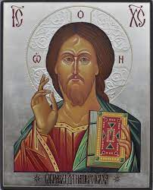
“God is love,” says St John in a famous line. There has never been a more radical statement in the history of humanity. To understand its original contrast with the generally accepted accounts of divinity in the ancient world is to grasp afresh its revolutionary quality.
The ancients could get behind power: God is mighty. God is holy. You cannot look on him and live. He dwells in unapproachable light. These sentiments, appearing frequently in the Old and New Testaments, are also common in the religious outlook of humanity outside of the biblical revelation.
The Romans not only conceived of the gods as powerful, but they viewed power itself as divine. This is why the emperor was a god: he held real power. He spoke and things happened. And the initial portrait of God from the first page of Scripture show a supreme power whose very speech brings into being the ordered cosmos. Similarly, knowledge. Zeus, for example, defeated his rivals and secured his power over the cosmos by his wily cunning which the Greeks prized above even strength. Now the God of biblical revelation is all-powerful and shrewd beyond the cunning of his creatures. He has no rival. He belongs to a wholly unique category; he is the One, the beginning and the end, the Lord of lords, the Living God, a consuming fire—”my name is too wonderful,” he tells Manoah, the father of Samson. To Moses he responds with the devastating, “I am who I am.” The traditional gods of the world’s peoples always seem to represent aspects of the world that definitively transcend our control and thereby elucidate our mortality—our powerlessness and ignorance. The God of glory in the biblical story again and again surpasses such accounts in a matchless and dizzying way. It’s almost as if that speech-draining eclipse of pagan divinity by this categorically different God of power and knowledge is just a peek through a cracked door, a taste of brine in the air from an unfathomable sea just beyond the next turn of the path. Accompanying his “name” in his world-upending presence before Moses, mysterious words are proclaimed that elaborate its meaning. Among them are the following: “merciful and gracious, slow to anger, and abounding in steadfast love…” This love is a holy, righteous love, a love that is absolute and free, a love that alone can swallow up the paralyzing power of evil and death and injustice, a love that loves, as the gospel decisively reveals, through the end of mortality into a renewed, ultimate beginning. It is an inextinguishable flame, a fountain that is its own limitless source, a light and a life that never dims nor ceases to satisfy. “God is love.” To meditate on these three words through the sacred story they summarise is to initiate an approach to the mystery of God’s triune character, his three-fold unity.

W Chris Hackett

TRINITY SUNDAY “LOVER”+“BELOVED”+“LOVED”

Today we celebrate the mystery of the Trinity: one God in three persons. God is:
- The Lover (Father, Creator),
  - The Beloved (Son, Saviour), and
    - The Love which flows between them (Holy Spirit, Counsellor).

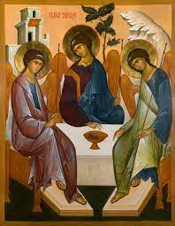
Previously, Pope Francis has said: ‘Trinity Sunday makes us contemplate this wonderful mystery of love and light from which we come and toward which our earthly journey is guided.’ “This Unity,” Pope Francis explained: “is essential to the Christian: it is not an attitude, an expression: no. It is essential, because unity is the only way of life. It is essential, because unity is born of love, of God's mercy, of the justification of Jesus Christ and of the presence of the Holy Spirit in our hearts.”

BAPTISM
Congratulations to Alexia Bazzano child of Zachary and Sarah, who will be baptised this weekend. We welcome her into our parish community and assure the family of our prayerful best wishes on this happy occasion.

FEASTS
Monday 5 June – St Boniface, bishop, martyr

MASS ON C31 (d.44)
For those unable to attend church due to illness or other reasons there is an opportunity to follow the 11.00am Sunday Mass from St. Patrick’s Cathedral, Melbourne, which is broadcast live on the TV station C31 Melbourne, which is channel 44 on digital TV.

COVID SAFE PRACTICES
- As we come in Church, we are asked to be aware of some good practice against the transmission of the Corona-virus.
- Please sanitise your hands as you enter the church and on the way before receiving Communion as well as on the way out of the Church. Hand Sanitiser Bottles are available at the entrances of the Church and at a seat as you walk to receive communion. Please receive Communion only on the Hand.
- Masks are not compulsory but recommended. You may wish to wear it or not.
- While distributing communion, Ministers of Communion, if they wish, do not have to wear masks anymore, it’s optional.
- THANKS to all those who have been and continue to be of great help to keep following well the required measures of Covid-19.

POPE FRANCIS' JUNE PRAYER INTENTION
- FOR ABOLITON OF TORTURE

(Torture is not past history. Unfortunately, it's part of our history today.)

“Let us pray that the international community may commit itself concretely
to abolish torture, guaranteeing support to victims and their families.”

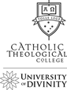 | Catholic Theological College  Find Your Path at CTC Online Information Session  Monday 19 June at 7.30pm (AEST)  Register via our website: ctc.edu.au/information-session  For more information contact:  Dr Christopher Knauf ctc.edu.au/contact/contact-the-registrar/

FOR A SYNODAL CHURCH: COMMUNION, PARTICIPATION AND MISSION
PRAYER FOR THE SYNOD: Adsumus Sancte Spiritus
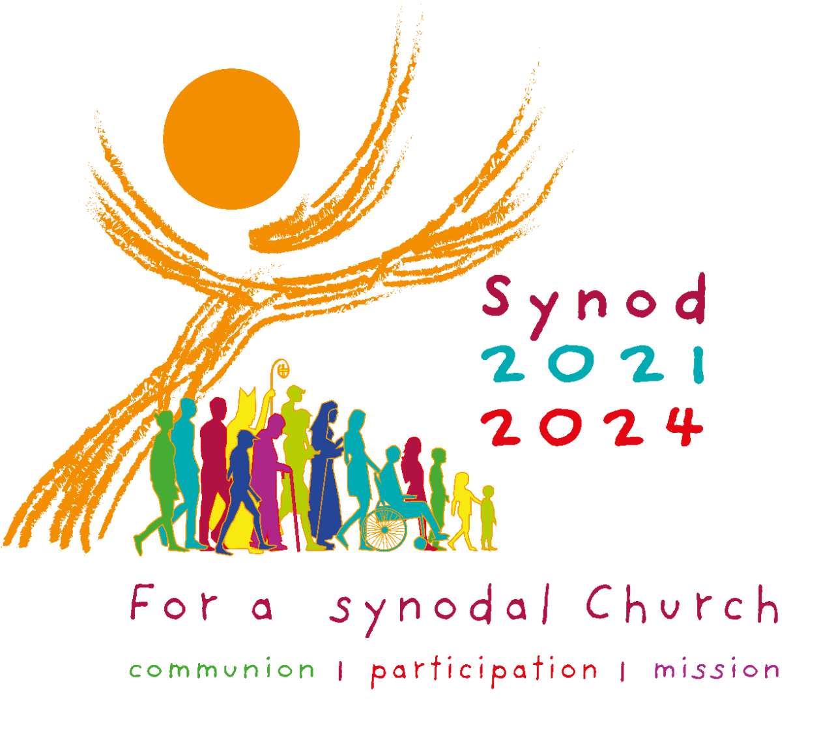
We stand before You, Holy Spirit, as we gather together in Your name. With You alone to guide us, make Yourself at home in our hearts; Teach us the way we must go and how we are to pursue it. We are weak and sinful; do not let us promote disorder. Do not let ignorance lead us down the wrong path nor partiality influence our actions. Let us find in You our unity so that we may journey together to eternal life and not stray from the way of truth and what is right. All this we ask of You, who are at work in every place and time, in the communion of the Father and the Son, forever and ever. Amen. More information www.synod.va

SHIP VISITORS WANTED
Stella Maris Seafarers’ Centre in Melbourne needs more volunteer ship visitors to provide a vital service to Seafarers in need. You will go on board vessels and approach Seafarers as friends, listening to their concerns and where possible offering practical help. For example, providing phone cards, organising transport, emergency medicine or vaccines and arranging for Mass or Liturgy on board. Email: leeanne.diano@stellamaris.org.au for more information

PALMS MISSION: TRANSFORM LIVES - THEIRS...AND YOURS
Communities in Africa, Asia or the Pacific are seeking Australians from a variety of professions and trades to share their skills and knowledge with those who have few other chances for training. Build enduring global relationships while assisting sustainable, self-reliant, community development. Explore 35 positions on our website. You can also see news including stories from those currently supported in Timor-Leste, Samoa, American Samoa and Thailand. Enquiries Tel: 02 9560 5333 or 0422 472 567.
WEB: www.palms.org.au

The Parish of St Joseph the Worker, North Reservoir and the Diocese of Melbourne are committed to the care, wellbeing and protection of children, young people and vulnerable people in our communit

