As we come and worship, we remember the wurundjeri people, the original custodians of this land

FIRST READING Jeremiah 20:10-13
He has delivered the soul of the needy from the hands of those who are evil.

RESPONSORIAL PSALM SALMO RESPONSORIALE
Lord, in your great love, answer me. | Nella tua grande bonta’ rispondimi, o Dio.
SECOND READING Romans 5:12-15
God’s gift to us is nothing like our sin against him.

GOSPEL ACCLAMATION CANTO AL VANGELO
Alleluia, alleluia!  The Spirit of Truth will bear witness to me, says the Lord, and you also will be my witnesses. Alleluia! | Alleluia, alleluia.  Lo Spirito della verita’ dara’ testimonianza di me, dice il Signore, e anche voi date testimonianza. Alleluia.
GOSPEL Matthew 10:26-33
Do not fear those who can kill the body.

THANKS TO THOSE WHO GAVE LAST WEEK
^{st} Collection - Thanksgiving Offering…………………………..$441.00
- Loose Money…………………………………….$246.00
2nd Collection - Presbytery………………………………………..$239.00

PLEASE NOTE THAT THOSE WHO ARE ROSTERED ON TO READ OR GIVE COMMUNION AT MASS ARE KINDLY ASKED, IF POSSIBLE, TO ARRIVE 10 MINUTES BEFORE MASS STARTS

LECTORS - THIS WEEK 25/06/2023 SPECIAL MINISTERS
5.30pm (SAT) – E Krygger M Mizzi & E Saliba
9.00am (SUN) – L Calafiore & P Sparano M & T Forte & R Alberti
10.30am (SUN) – H Joy Lopez D Nguyen & V De Leo
LECTORS – NEXT WEEK 02/07/2023 SPECIAL MINISTERS
5.30pm- MALTESE MASS (Selected) MALTESE MASS (Selected)
9.00am- C Brunetti & G Barbaro F Pascuzzi,O Strangis & L Calafiore
10.30am- V De Leo G Caruana & R Iuele

YOUR PRAYERS ARE REQUESTED FOR THE FOLLOWING RECENTLY DECEASED Fr Paolo CARDONA (Gozo, Malta), Sebastiano DE CARO
Michele GUCCIONE, Ferdinando GRANDENETTI (d.Rec. Italy), Vincent TRINH,
Giuseppina MANNO

ANNIVERSARIES & SPECIAL MEMORIES
Pasquale STIVALA, Anglu ATTARD, Harold KENNAN, Pietro RIPOLI, Salvatrice FORMICA
Felice TARANTO, Amalia MULTARI, Alfonsina AMORE, Antonio & Famiglia PICIONERI,
Francesco, Concetta & Famiglia PAPALIA,

ST JOSEPH THE WORKER
_______________________________________NORTH RESERVOIR _________________________________________

79 Wilson Boulevard, North Reservoir 3073

Parish House/Office Tel: 9460 3013 Fax: 9460 8832
Email: Parish@stjosephtheworker.org.au
www.stjosephtheworker.org.au
School Tel: 9469 7800 Fax: 9462 2949

SUNDAY MASS TIMES: Fr Emmanuel Bonello–Parish Priest WEEKDAY MASS TIMES:

Mb: 0431 643 674

Sat 5.30pm - English Mrs Maria Barnes – School Principal
Sun. 9.00am - Italian Mrs Liz Pistoni – Parish Secretary Tue. 10.00am Italian

Sun. 10.30am – English Wed. 9.10am - English

Thur. 9.10am - English

Maltese Mass Fri. 9.10am - English Sat. 8.30am - English
1st Saturday of the Month 5.30pm Sat. 8.30am-English
Baptisms – Sunday 12.00pm Reconciliation:
Marriages – by Appointment (Individual Confessions)
Sat. 5.00pm or by Appointment

12th Sunday in Ordinary Time Year A 25 June, 2023
We are precious in god’s eyes


When I was a young boy shopping with my mum, she would remind me when we entered a shop to look but not to touch. She would say, “Those things are expensive. They break easily.”
Her words have always stayed with me. Expensive items are not to be handled, as high cost equates to fragility. This is a pertinent experience for our everyday lives. When I used to drive an old, damaged car, I didn’t really care where I was parked or who was parked next to me. However later, when driving a much newer and more expensive vehicle, I was very careful not to park near the supermarket trolleys or next to an old, battered car like the one I had before. I treated the newer car like a fragile item that could shatter and break. I was so cautious that, in my mind, I bubble-wrapped my car. So, it is with our lives. Newborn babies are fragile and immensely precious. I have heard young dads and mums share stories about how they held their newborns in their arms or in the palm of their hands and marvelled at their preciousness. As we grow up, our parents naturally try to bubble-wrap us to protect us from dangers around us.
Eventually, as we grow and journey through life, the bubble-wrap falls away. But the preciousness of our lives is still there and does not detract from the reality that each of us is precious.
That is the message Jesus shares with his disciples in today’s gospel passage. “Can you not buy two sparrows for a penny? And yet not one falls to the ground without your Father knowing. Why? Every hair on your head has been counted. So, there is no need to be afraid; you are worth more than hundreds of sparrows.” Like everyone, I have had hard knocks in my own life. Some of those personal blows were difficult to bounce back from. But, as I recall those times, I remember the pain on my parents’ faces; it said it all. If they could have taken my place and spared me the hurt, they would have. And that love and support is what gave me the strength to stand up again. My parents’ response provides a glimpse of the love and care that God has demonstrated to us through the life and sacrifice of His son, Jesus. Their love for me exemplifies the immense love God has for each one of us. God doesn’t want us in bubble-wrap: to be seen and not touched. God wants us to live our lives to the full and to do the work we are called to do, helping to build a better world. Jesus encouraged his disciples not to be afraid. We are precious in God’s eyes. Even though we can be fragile and vulnerable, God values and loves us and is always by our side.
Mark Chia CSsR

FR MANNY’S 40th ANNIVERSARY OF PRIESTHOOD

SUNDAY 25th June 2023

During this weekend’s masses Fr Manny will be celebrating in thanksgiving for his 40th Anniversary of Priesthood. This Weekend on Sunday 25th June 2023 after the 10.30am mass in the Church’s narthex, there will be a cup of Coffee or Tea and the cutting of the cake. On this occasion of the priesthood’s 40th anniversary Fr Manny is very grateful to everyone for every support, help and prayers. Thank you.

BAPTISM
Congratulations to Gianni Ferretti child of Matthew and Sandra, who will be baptised this weekend. We welcome Gianni into our parish community and assure the family of our prayerful best wishes on this happy occasion.

ADORAZIONE EUCARISTICA
Martedi 27 Giugno Adorazione Eucaristica ore 9.00am, Segue S. Messa ore 10.00am.

MALATESE MASS
A reminder that the Maltese Mass will be celebrated next Saturday 1 July at 5.30pm.

FEASTS
Wednesday 28 June: Saint Irenaeus, bishop, martyr
Thursday 29 June: Sts PETER and PAUL, apostles

ABORIGINAL AND TORRES STRAIT ISLANDER
SUNDAY 2 JULY 2023
“A NEW LIFE IN CHRIST”

Next Sunday 2 July 2023 will be the Aboriginal and Torres Strait Islander Sunday with the reflective theme: ‘A NEW LIFE IN CHRIST’.
The following is a Voice Prayer:
Dear Lord, we invite all Australians to join us, their Aboriginal and Torres Strait Islander Brothers and Sisters in prayer. We pray for a bright and just shared future for all who call Australia home. We ask that Your grace of acceptance and compassion will guide us. Let the Creator Spirit lead our journey with the Aboriginal and Torres Strait Islander Peoples of this land. May we share Your Spirit more deeply & celebrate the gifts You have given us. Help us appreciate true harmony and peace just as our Old People did; Keep us strong, make us resilient and remember us in this time. Now is an opportunity to change our Nation’s history for the better. Walk with us as we write a new chapter together and may we be one in Your love. Amen.

MASS ON C31 (d.44)
For those unable to attend church due to illness or other reasons there is an opportunity to follow the 11.00am Sunday Mass from St. Patrick’s Cathedral, Melbourne, which is broadcast live on the TV station C31 Melbourne, which is channel 44 on digital TV.

COVID SAFE PRACTICES
- As we come in Church, we are asked to be aware of some good practice against the transmission of the Corona-virus.
- Please sanitise your hands as you enter the church and on the way before receiving Communion as well as on the way out of the Church. Hand Sanitiser Bottles are available at the entrances of the Church and at a seat as you walk to receive communion. Please receive Communion only on the Hand.
- Masks are not compulsory but recommended. You may wish to wear it or not.
- While distributing communion, Ministers of Communion, if they wish, do not have to wear masks anymore, it’s optional.
- THANKS to all those who have been and continue to be of great help to keep following well the required measures of Covid-19.

POPE FRANCIS' JUNE PRAYER INTENTION
- FOR ABOLITON OF TORTURE

(Torture is not past history.
Unfortunately, it's part of our history today.)

“Let us pray that the international community may commit itself concretely
to abolish torture, guaranteeing support to victims and their families.”

FOR A SYNODAL CHURCH: COMMUNION, PARTICIPATION AND MISSION
PRAYER FOR THE SYNOD: Adsumus Sancte Spiritus
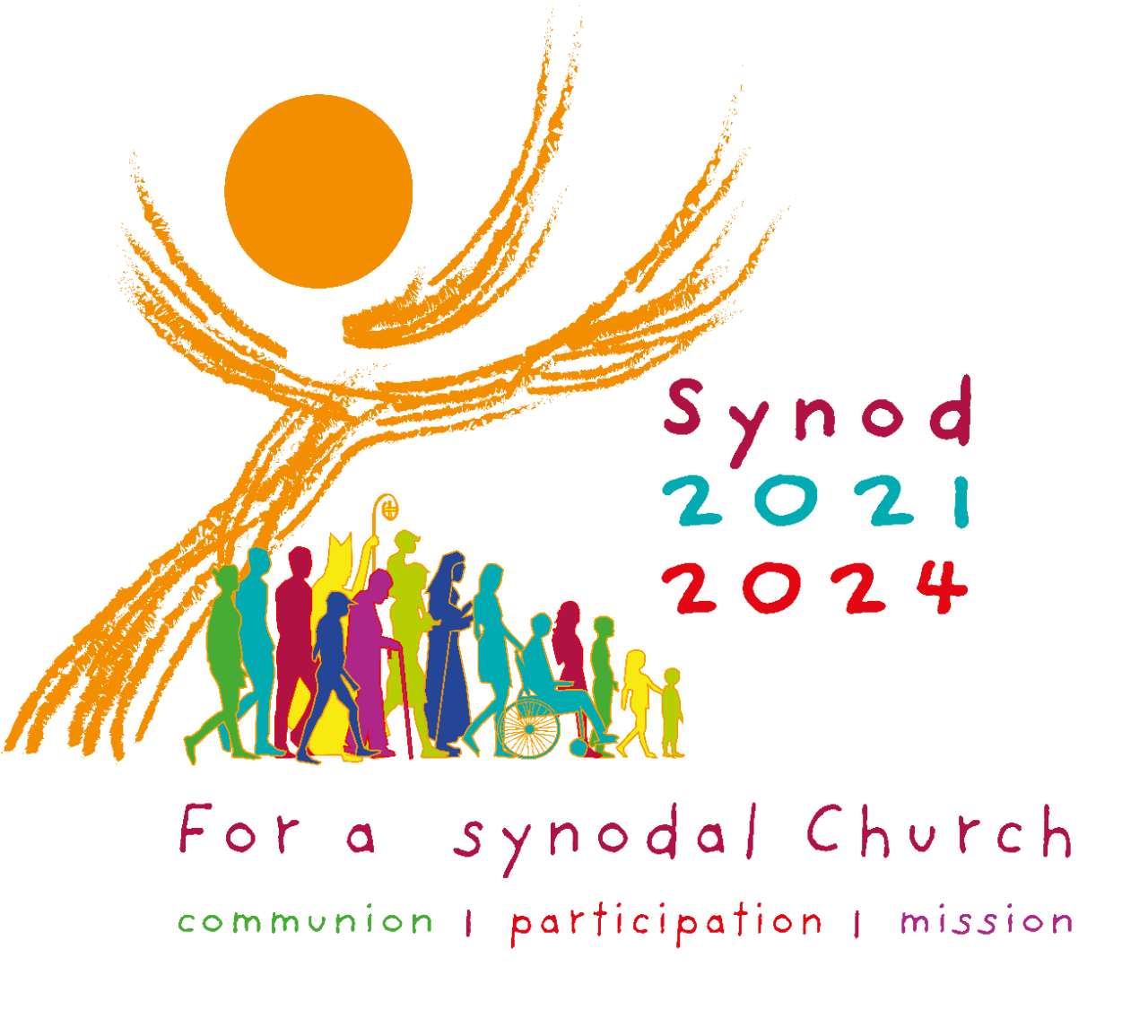
We stand before You, Holy Spirit, as we gather together in Your name. With You alone to guide us, make Yourself at home in our hearts; Teach us the way we must go and how we are to pursue it. We are weak and sinful; do not let us promote disorder. Do not let ignorance lead us down the wrong path nor partiality influence our actions. Let us find in You our unity so that we may journey together to eternal life and not stray from the way of truth and what is right. All this we ask of You, who are at work in every place and time, in the communion of the Father and the Son, forever and ever. Amen. More information www.synod.va

The Parish of St Joseph the Worker, North Reservoir and the Diocese of Melbourne are committed to the care, wellbeing and protection of children, young people and vulnerable people in our communit

