As we come and worship, we remember the wurundjeri people, the original custodians of this land

FIRST READING Kings 4:8-11, 14-16
That is the holy man of God, let him remain there.

RESPONSORIAL PSALM SALMO RESPONSORIALE
For ever I will sing the goodness of the Lord. | Cantero’ per sempre l’amore del Signore.
SECOND READING Romans 6:3-4, 8-11
Having been buried with him through baptism, we shall walk in a new life.

GOSPEL ACCLAMATION CANTO AL VANGELO
Alleluia, alleluia!  You are a chosen race, a royal priesthood, a holy people. Praise God who called you out of darkness and into his marvellous light. Alleluia! | Alleluia, alleluia.  Voi siete stirpe eletta, sacerdozio regale, nazione santa; proclamate le opere ammirevoli di colui che vi ha chiamato dalle tenebre alla sua luce meravigliosa. Alleluia.
GOSPEL Matthew 10:37-42
Anyone who does not accept his cross is not worthy of me. Anyone who welcomes you, welcomes me..

THANKS TO THOSE WHO GAVE LAST WEEK
^{st} Collection - Thanksgiving Offering…………………………..$425.00
- Loose Money…………………………………….$369.00
2nd Collection - Presbytery………………………………………..$273.00

PLEASE NOTE THAT THOSE WHO ARE ROSTERED ON TO READ OR GIVE COMMUNION AT MASS ARE KINDLY ASKED, IF POSSIBLE, TO ARRIVE 10 MINUTES BEFORE MASS STARTS

LECTORS - THIS WEEK 02/07/2023 SPECIAL MINISTERS
5.30pm (SAT) – MALTESE MASS (Selected) MALTESE MASS (Selected)
9.00am (SUN) – C Brunetti & G Barbaro F Pascuzzi, O Strangis & L Calafiore
10.30am (SUN) – V De Leo G Caruana & R Iuele
LECTORS – NEXT WEEK 09/07/2023 SPECIAL MINISTERS
5.30pm- D Pullicino B Nadenbousch & N Ziino
9.00am- C Agostinelli & F Pascuzzi F Multari, G Barbaro & M Sinopoli
10.30am- L De Marco B Clark-Loh & S Rottura

YOUR PRAYERS ARE REQUESTED FOR THE FOLLOWING RECENTLY DECEASED
Giuseppina BATTISTA, Paul ATTARD

ANNIVERSARIES & SPECIAL MEMORIES
Giuseppe & Angelina TODARO, Iris FAVA, Christine GALLINARO, Maria-Grazia MURDICA
Domenico MORANO, Rocco MORANO, Anna DIMASE, Paolo & Giuseppina NASELLI,
Jospeh GRECH, Tommaso CAMPO, Luciano & Famiglia VALMORBIDA,MOREE,
Famiglia DEL ZOTTI, Betty PELUSO, Antoneitta CRITELLI, Nicola DI GUGLIELMO

ST JOSEPH THE WORKER
_______________________________________NORTH RESERVOIR _________________________________________

79 Wilson Boulevard, North Reservoir 3073

Parish House/Office Tel: 9460 3013 Fax: 9460 8832
Email: Parish@stjosephtheworker.org.au
www.stjosephtheworker.org.au
School Tel: 9469 7800 Fax: 9462 2949

SUNDAY MASS TIMES: Fr Emmanuel Bonello–Parish Priest WEEKDAY MASS TIMES:

Mb: 0431 643 674

Sat 5.30pm - English Mrs Maria Barnes – School Principal
Sun. 9.00am - Italian Mrs Liz Pistoni – Parish Secretary Tue. 10.00am Italian

Sun. 10.30am – English Wed. 9.10am - English

Thur. 9.10am - English

Maltese Mass Fri. 9.10am - English Sat. 8.30am - English
1st Saturday of the Month 5.30pm Sat. 8.30am-English
Baptisms – Sunday 12.00pm Reconciliation:
Marriages – by Appointment (Individual Confessions)
Sat. 5.00pm or by Appointment

13th Sunday in Ordinary Time Year A 2 July, 2023
Not an easy life

One of St Paul’s proudest boasts was that he had worked harder, travelled further and suffered a great deal more than any of the other apostles (1 Cor 15:9-10). In 2 Corinthians (6:3-13; 11:23-33) he catalogues the trials and tribulations he had experienced for the sake of his “children” (6:13), which included “far more imprisonments, far worse beatings, and numerous brushes with death” (11:23). What made this even more remarkable is Paul’s age. Paul would have been close to sixty years of age when he was evangelising the cities of the Aegean Basin. By the time he wrote Romans, from which we derive our second reading today, he would have been in his mid-60s.
As implied by his list of troubles in 2 Corinthians, Paul’s career was anything but a “cake walk”; nor was it a career that involved a well-deserved retirement in his twilight years. He was beheaded in Rome around the year 64 CE, along with many other Christians who died at the behest of the Emperor Nero. Paul stands as a clear example of one who chose the “good life” over a “comfortable life”. He stood up for what he believed. He stood out by travelling, writing, and building up Christianity. But, in doing so, his life was far from comfortable. Matthew’s Jesus similarly warns his disciples that choosing to follow him will involve tough decisions. The irony of the biblical record is that the immediate “reward” for all of those who chose to live a good life is all-too-often hardship, misunderstanding, persecution and even death at the hands of their persecutors. Sometimes, these difficulties will even be visited upon us from within our family circle. This passage in Matthew will reverberate throughout the rest of the gospel, most notably for our purposes in Matthew 13:54- 58, where Jesus returns to his hometown. He enters the Synagogue expecting a ready welcome from his former neighbours and friends, only to encounter misunderstanding and disbelief. Jesus observes that “Prophets are not without honour except in their own country and in their own house” (Mt 13:57). We might think of this episode as a first century Judaean form of the Australian “tall poppy syndrome” – the tendency to discredit rising stars whom the mob believes are too “full of themselves” or “take themselves too seriously”. The fear of ridicule and misunderstanding may tempt us to forego making the tough decisions or the right choices in life. We don’t want to stand out or stand up for fear of being knocked down, especially in matters of public faith-practice. But as Paul and Jesus testify, standing up and standing out is the only real path to the good life – that is, a life built on purpose and meaning.
Ian J Elmer

THANK YOU FROM FR MANNY
Fr Manny wish to thank all the St. Joseph the Worker North Reservoir Parishioners and friends for the expressions of good wishes, blessings, gifts, support and prayers on his 40th anniversary of priesthood on 25th June 2023.

GRAZIE DA PADRE MANNY
Padre Manny ringrazia tutti i parrocchiani ed amici di S. Giuseppe Lavoratore, North Reservoir per l’espresioni di auguri, benedizioni, doni, appogio, e preghiere nel suo 40mo anniversario di Sacerdozio 25 Giugno 2023.

BAPTISM
Congratulations to Charlotte Pell child of Daniel and Vanessa, who will be baptised this weekend. We welcome Charlotte into our parish community and assure the family of our prayerful best wishes on this happy occasion.

FEAST
Monday 3 July: St Thomas, apostle

MASS ON C31 (d.44)
For those unable to attend church due to illness or other reasons there is an opportunity to follow the 11.00am Sunday Mass from St. Patrick’s Cathedral, Melbourne, which is broadcast live on the TV station C31 Melbourne, which is channel 44 on digital TV.

COVID SAFE PRACTICES
- As we come in Church, we are asked to be aware of some good practice against the transmission of the Corona-virus.
- Please sanitise your hands as you enter the church and on the way before receiving Communion as well as on the way out of the Church. Hand Sanitiser Bottles are available at the entrances of the Church and at a seat as you walk to receive communion. Please receive Communion only on the Hand.
- Masks are not compulsory but recommended. You may wish to wear it or not.
- While distributing communion, Ministers of Communion, if they wish, do not have to wear masks anymore, it’s optional.
- THANKS to all those who have been and continue to be of great help to keep following well the required measures of Covid-19.

FOR A SYNODAL CHURCH: COMMUNION, PARTICIPATION AND MISSION
PRAYER FOR THE SYNOD: Adsumus Sancte Spiritus
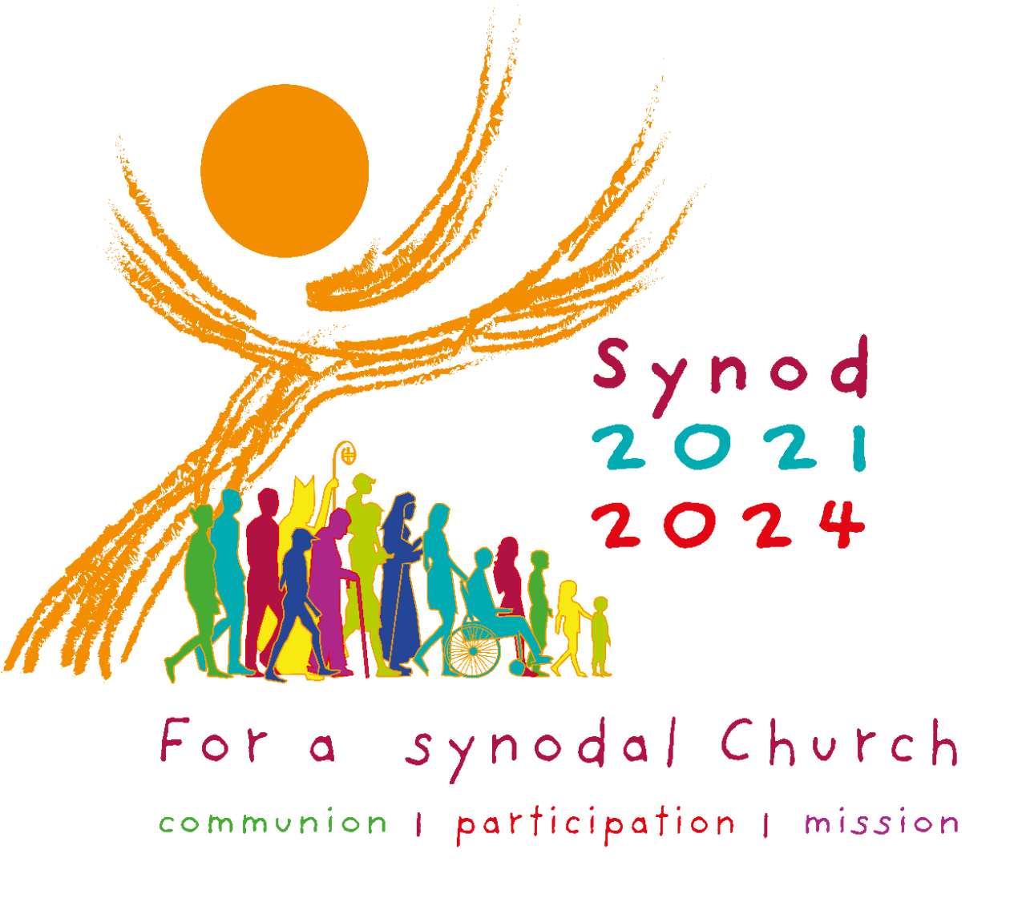
We stand before You, Holy Spirit, as we gather together in Your name. With You alone to guide us, make Yourself at home in our hearts; Teach us the way we must go and how we are to pursue it. We are weak and sinful; do not let us promote disorder. Do not let ignorance lead us down the wrong path nor partiality influence our actions. Let us find in You our unity so that we may journey together to eternal life and not stray from the way of truth and what is right. All this we ask of You, who are at work in every place and time, in the communion of the Father and the Son, forever and ever. Amen. More information www.synod.va

ABORIGINAL AND TORRES STRAIT ISLANDER
SUNDAY 2 JULY 2023
“A NEW LIFE IN CHRIST”

Each year, Catholics from all corners of Australia gather on Aboriginal and Torres Strait Islander Sunday to celebrate the unique gifts and contributions of Australia’s First Peoples. This year’s reflective theme which is: “A NEW LIFE IN CHRIST” reflects the hope and promise of a brighter future, rooted in unity and shared commitment to positive change. As w commemorate this special day this weekend, on the Liturgical Calendar, we are invited to listen to the First People’s voices and walk alongside with them on a journey towards progress. Aboriginal and Torres Strait Islander Sunday symbolizes our unity as one people in Christ.

The following is a Voice Prayer:
Dear Lord, we invite all Australians to join us, their Aboriginal and Torres Strait Islander Brothers and Sisters in prayer. We pray for a bright and just shared future for all who call Australia home. We ask that Your grace of acceptance and compassion will guide us. Let the Creator Spirit lead our journey with the Aboriginal and Torres Strait Islander Peoples of this land. May we share Your Spirit more deeply & celebrate the gifts You have given us. Help us appreciate true harmony and peace just as our Old People did; Keep us strong, make us resilient and remember us in this time. Now is an opportunity to change our Nation’s history for the better. Walk with us as we write a new chapter together and may we be one in Your love. Amen.

CATHOLIC MISSION APPEAL NEXT WEEK 8/9 JULY

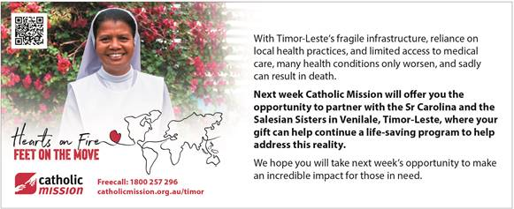

The Parish of St Joseph the Worker, North Reservoir and the Diocese of Melbourne are committed to the care, wellbeing and protection of children, young people and vulnerable people in our communit

