As we come and worship, we remember the wurundjeri people, the original custodians of this land

FIRST READING Genesis 9:8-15
I will recall the covenant between myself and you…the waters shall never again become a flood to destroy all flesh.

RESPONSORIAL PSALM SALMO RESPONSORIALE
Your ways, O Lord, are love and truth to those who keep your covenant. | Tutti i sentieri del Signore sono amore e fedelta’.
SECOND READING St Peter 3:18-22
The water of the flood is a type of the baptism which saves you now.

GOSPEL ACCLAMATION CANTO AL VANGELO
Praise to you, Lord Jesus Christ, king of endless glory!  No one lives on bread alone, but on every word that comes from the mouth of God.  Praise to you, Lord Jesus Christ, king of endless glory! | Lode a te, o Cristo, re di eterna gloria!  Non di solo pane vivra’ l’uomo, ma di ogni parola che esce dalla bocca di Dio.  Lode a te, o Cristo, re di eterna gloria!
GOSPEL Mark 1:12-15
He was tempted by Satan, and the angels looked after him.

THANKS TO THOSE WHO GAVE LAST WEEK
1st Collection - Thanksgiving Offering…………………………..$550.00
- Loose Money…………………………………….$277.00
2nd Collection - Presbytery………………………………………..$280.00

PLEASE NOTE THAT THOSE WHO ARE ROSTERED ON TO READ OR GIVE COMMUNION AT MASS ARE KINDLY ASKED, IF POSSIBLE, TO ARRIVE 10 MINUTES BEFORE MASS STARTS
LECTORS - THIS WEEK 18/02/2018 SPECIAL MINISTERS
6.00pm (SAT) – D Pullicino & G Canavan N Ziino & T Nguyen
9.00am (SUN) – R Fato & M Crupi M Piscioneri, M Forte, G Tempone & C Alberti
10.30am (SUN) – T Nguyen & L De Marco S Dakin, J Iaria, B Clark-Loh, M Mizzi
& T Nguyen
LECTORS – NEXT WEEK 25/02/2018 SPECIAL MINISTERS
6.00pm (SAT) E Saliba & Sr T Fitzsimmons R Iuele & P Nguyen
9.00am (SUN) – R Pino & L Cavedon G Calvi, O Strangis, A Sonza & M Piscioneri
10.30am (SUN) – L Conte & A Valentini T Nguyen, E Bartlett, L De Marco,
J Mengolian & D Schembri
MONEY COUNTERS 19/02/2018 F Nardozza, I Manini, R Comito & G Li Rosi
26/02/2018 E Claridge & S Dakin

YOUR PRAYERS ARE REQUESTED FOR THE FOLLOWING RECENTLY DECEASED Felicia UBALDI, Lewis PORTELLI, Wenzu RAPA, Salvu BONELLO
Joseph FARRUGIA, Jean-France HENNEQUIN
ANNIVERSARIES & SPECIAL MEMORIES Concetta NICOLAZZO, Angela FOTI,
Giovanni QUADARA (60 anniversario), Laura & Pasquale MARIANI, Lorenzo & Rachele PACELLA
Antonino & Costanza CARNOVALE, Giuseppe CARNOVALE, Gina DI DONATO, Maria SACCUZZO,
Tullio FANTIN, Luigi CAVEDON, Antonio PASCUZZI, Tonino NAPOLITANO,Pasquale TIMPANO

ST JOSEPH THE WORKER
_______________________________________NORTH RESERVOIR _________________________________________

79 Wilson Boulevard, North Reservoir 3073

Parish House/Office Tel: 9460 3013 Fax: 9460 8832
Email: Parish@stjosephtheworker.org.au
www.stjosephtheworker.org.au
School Tel: 9469 7800 Fax: 9462 2949

SUNDAY MASS TIMES: Fr Emmanuel Bonello–Parish Priest WEEKDAY MASS TIMES:

Mb: 0431 643 674

Sat 6.00pm - English Sr Estelita Manabo-Pastoral Associate Mon. 9.10am Comm. Service
Sun. 9.00am - Italian Mrs Maria Barnes -School Principal Tue. 10.00am Italian

Sun. 10.30am – English Mrs Liz Pistoni – Parish Secretary Wed. 9.10am - English

Thur. 9.10am - English

Maltese Mass Fri. 9.10am - English Sat. 8.30am - English
1st Saturday of the Month 6.00pm Sat. 8.30am - English Sat. 8.30am-English
Baptisms – Sunday 12.00pm Reconciliation: Sat. 10.30am
Marriages - By Appointment

1st Sunday of Lent, Year B 18 February, 2018
Taking Stock

Unlike Matthew and Luke, who both give us detailed descriptions of the way Jesus was tempted in the wilderness, Mark sums it up in a few sentences. There is an urgency about the whole of Mark’s gospel. He was writing for the persecuted Christians in Rome, for whom their faith was truly a matter of life and death.
They might well be called upon to confront the wild beasts in the Colosseum and Mark wanted them to know that in essence the battle was already won for them. Likewise, Jesus had to confront the opposition of the evil one, Satan, but “the kingdom of God was close at hand”. John the Baptist had done his job and had been arrested, but Jesus had then taken over and established the kingdom in himself. Therefore, no matter what befalls us, the Good News is there for us if we repent and believe.
The ancient scriptures had glimpsed the fulfilment of God’s ultimate promise when, after the flood, there appeared a rainbow in the sky: a sign of the new covenant being established with Noah. In his first letter, Peter links the covenants by seeing the water of the flood as a sign of the waters of baptism, which do not just wash us clean, but unite us to Christ and his resurrection and all that will follow.
No matter that the body has to face death, “in the spirit Jesus was raised to life” and, of course, we can expect the same. Like Mark, Peter is trying to bolster the persecuted men and women of the early Church so they would stand firm.
The reality is that we too have to confront the demons in our lives. Sometimes we recognise these demons inside ourselves, tempting us to addictions or ways of life that we know are not healthy. Sometimes the demons are evident in the chaos that reign in our world, whether they originate in the natural order such as floods and bushfires or whether they arise from the oppressive behaviour of other human beings who disorder the world by their destructive abuse of power and their selfish and callous actions.
Lent provides us with an opportunity to take stock. During these weeks the Church encourages us to enter into the wilderness of the spiritual life and confront our demons. It is an invitation, not to be miserable or negative, but to continue to reorder our lives in the light of the Good News of Jesus.
Angels are God’s messengers and they ministered to Jesus. Our aim during Lent is surely to become ministering angels to Christ in all those who continue to suffer the injustices and oppressions of a world, where so many still have a long way to go before they even begin to embrace the Good News.

Timothy J Buckley CSsR

ASSOCIAZIONE SAN GABRIELE DELL’ADDOLORATA

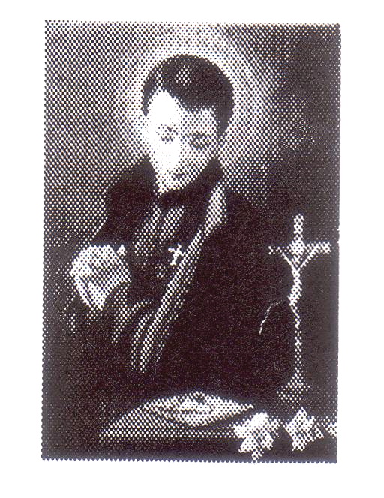
Domenica 18 Febbraio festa in onore di San Gabriele patrono dell’Abruzzo e dei giovani. Monastero dei Padri Passionisti Holy Cross, Serpells Rd Templestowe.

Domenica 18 Febbraio 10.00am – Santo Rosario
10.30am – Santa Messa concelebrata da padre Michele Messi proveniente dal Santuario di San Gabriele e da padre kevin superiore di Holy Cross.
Partecipazione della Corale di Sant’Antonio, benedizione dei malati. Seguira’ processione accompagnata dalla Banda Bellini. Al termine celebrazione relgiosa esibizione del coro della Casa da Abruzzo e picnic (BYO) con prochetta, gnocchi, gelati e soft drink. 2.00pm – 4.30pm Show del Duo Musicale Tony Di Iorio.

Informazioni: Renato & Lucia Catena 9460 4597

BAPTISM
Congratulations to Juliette Pascuzzi child of Joseph and Lesley, who will be baptised this weekend. We welcome her into our parish community and assure the family of our prayerful best wishes on this happy occasion.

VIA CRUCIS – STATIONS OF THE CROSS PRAYERS
Stations of the Cross Prayers every Friday during Lent (English and Italian) at 7.00pm.

QUARESIMA: TEMPO DI PREGHIERA E RIFLESSIONE
Martedi 20 Febbrario ore 9.15am in Cappella seguita dalla S. Messa, ore 10.00am. Vi aspettiamo numerosi.

PARISH PASTORAL TEAM
The Parish Pastoral Team Meeting will be held on Wednesday 21 February at 7.30pm in the Presbytery.

2018 STATE SCHOOL CHILDREN – SACRAMENTAL LESSONS
2018 State School Children – Sacramental Lessons.
Registration Forms/Information Letters available from the Parish Office or Sr Estelita.

PRAYER FOR THE HEALING OF VICTIMS OF ABUSE
Loving Father, since your mercy has been revealed in the tenderness of your Son Jesus Christ, who said to his disciples: “Let the little children come to me”, we pray that your Church may be a secure home where all children and vulnerable adults are brought closer to your Beloved Son. May all those who have been abused physically, emotionally and sexually by your ministers, be respected and accompanied by tangible gestures of justice and reparation so that they may feel healed with the balm of your compassion.
We ask this through Jesus Christ our Lord. Amen
ST VINCENT’S HOSPITAL FUN RUN
Sunday 15 April, 9.30am, Princes Park, Royal Parade, Carlton North
As part of their 125th birthday celebrations, this year’s St Vincent’s Fun Run promises to be an exciting and rewarding family fun day.
Registration: www.stvincentsfunrun.com.au



First Sunday of Lent
18th February 2018
Bishop Greg O’Kelly of Port Pirie and Caritas Australia Chairman invites us for Project Compassion 2018 celebrating “A just future for all in conjunction with the year of Youth” This year’s Project Compassion shares with us stories of Janaki from Nepal, Rattanak from Cambodia, Bayan from Jordan, Evangeline from Australia, Ditosa from Mozambique, and Psyche Mae from the Phillipines. This Lent we hope to demonstrate how A Just Future is possible for all generations, backgrounds, cultures and communities, who are part of one human family.
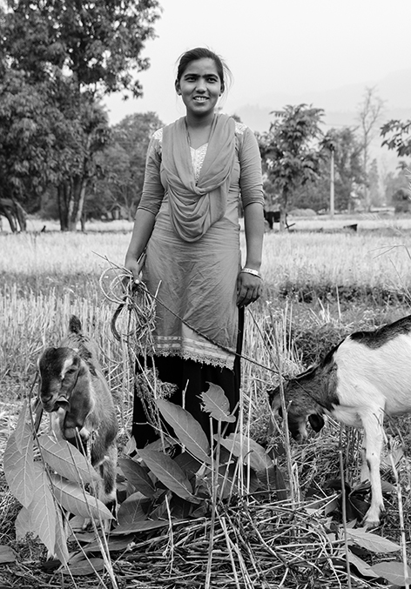
Janaki is a young entrepreneur from Nepal, who has turned her life around. Growing up in a world of poverty and disadvantage, coupled with a forced marriage at the age of twelve, she was in a very vulnerable position. Even more so when her husband died just two years into their marriage. With the help of a Caritas Australia supported program she is now running her own successful sewing business and has become an inspirational community leader.
PRAYER
For our sisters and brothers around the world who are journeying out of the wilderness to ‘a just future’, that their desire to serve their community be an example for us to follow.

Please donate to Project Compassion 2018 and help our most neighbours in Nepal to build a just future for their families and their communities.
A Just Future starts with your support! Please pick up a project compassion box available in the Narthex and near the Church side Door. Thank you.

MALTA’S OLDEST DEVOTIONAL FEAST “jESUS THE REDEEMER.”
Sunday 4 March 2018. St Mary”s Star of the Sea Church 33 Howard Street, West Melbourne
3.00pm Prayers & Rosary
3.30pm Solemn Mass celebrated by Most Rev. Bishop Hilton Deakin and other Priests.
After Mass Benediction, with the Blessed Sacrament.
Celebration will conclude with a street procession with statue of Jesus The Redeemer.
Himig Pilipono choir will provide the hymns. Everyone Welcome!
Associations/Clubs are invited to come and bring their Banners. Information: Joe 0400 357 001

YOUTH MASS WITH BISHOP TERRY CURTIN
Sunday 4 March, 6pm St Luke’s, 1A David Street, Lalor
The Australian Bishops have identified the liturgical year of 2018 as a national Year of Youth. They have entrusted the Year of Youth to the guidance of the Holy Spirit in this great south land, drawing inspiration from St Mary of the Cross MacKillop. The parish of St Luke’s in Lalor would like to invite one and all to this Youth Mass, as Bishop Terry Curtin joins with the entire Lalor community, families and friends in celebrating this special occasion. Details: 9465 2180

