As we come and worship, we remember the wurundjeri people, the original custodians of this land

FIRST READING Isaiah 55:6-9
My thoughts are not your thoughts.

RESPONSORIAL PSALM SALMO RESPONSORIALE
The Lord is near to all who call him. | Il Signore e’ vicino a chi lo invoca.
SECOND READING Philippians: 1:20-24,27
For me to live is Christ.

GOSPEL ACCLAMATION CANTO AL VANGELO
Alleluia, alleluia!  Open our hearts, O Lord,  to listen to the words of your Son.  Alleluia! | Alleluia, alleluia.  Apri, Signore, il nostro cuore e accoglieremo le parole del Figlio tuo. Alleluia!
GOSPEL Matthew 20:1-16
Why are you jealous because I am generous?

THANKS TO THOSE WHO GAVE LAST WEEK
1st Collection - Thanksgiving Offering…………………………..$600.00
- Loose Money…………………………………….$342.00
2nd Collection - Presbytery………………………………………..$334.00

PLEASE NOTE THAT THOSE WHO ARE ROSTERED ON TO READ OR GIVE COMMUNION AT MASS ARE KINDLY ASKED, IF POSSIBLE, TO ARRIVE 10 MINUTES BEFORE MASS STARTS
LECTORS - THIS WEEK 24/09/2017 SPECIAL MINISTERS
6.00pm (SAT) – D Pullicino & B Nadenbousch N Ziino & T Nguyen
9.00am (SUN) – C Brunetti & G Barbaro D Biasibetti, S Lobartolo, P Leggiero & L Calafiore
10.30am (SUN) – J Kearney & N Sua P Nguyen, D Schembri, V De Leo, M Mizzi
J Frangiosa
LECTORS – NEXT WEEK 01/10/2017 SPECIAL MINISTERS
6.00pm (SAT) E Saliba & Sr T Fitzsimmons R Iuele & P Nguyen
9.00am (SUN) – F Pascuzzi & M Crupi T Mirigliano, L Catena, A Sonza & G Barbaro
10.30am (SUN) – K Nguyen & V De Leo S Dakin, J Iaria, B C Loh, T Nguyen &
R Gatto MONEY COUNTERS 25/09/2017 E Claridge, F Carabott & G Canavan
02/10/2017 S Dakin & L De Marco

YOUR PRAYERS ARE REQUESTED FOR THE FOLLOWING RECENTLY DECEASED
Caterina ZAFFINO, Giovanna BUTERA, Giuseppe PIRAINA

ANNIVERSARIES & SPECIAL MEMORIES
Patrick MAHONY, Gaetano ATTARDO, Michelangelo GIGLIOTTI,Luciano GRANIERI,
Giuseppa Immacolata PAPALEO, Adrien MADIONA, Josephine MADIONA, Maria-Rosa CROCITTI,
Giuseppe TARANTO, Felice TARANTO, Bartolo –Bob PALAMARA, Vincenza CATENA,
Mario MACCIOCCA, Gina DI DONATO, Giovanna LI ROSI,

ST JOSEPH THE WORKER
_______________________________________NORTH RESERVOIR _________________________________________

79 Wilson Boulevard, North Reservoir 3073

Parish House/Office Tel: 9460 3013 Fax: 9460 8832
Email: Parish@stjosephtheworker.org.au
www.stjosephtheworker.org.au
School Tel: 9469 7800 Fax: 9462 2949

SUNDAY MASS TIMES: Fr Emmanuel Bonello–Parish Priest WEEKDAY MASS TIMES:

Mb: 0431 643 674

Sat 6.00pm - English Sr Estelita Manabo-Pastoral Associate Mon. 9.10am Comm. Service
Sun. 9.00am - Italian Mrs Maria Barnes -School Principal Tue. 10.00am Italian

Sun. 10.30am – English Mrs Liz Pistoni – Parish Secretary Wed. 9.10am - English

Thur. 9.10am - English

Maltese Mass Fri. 9.10am - English Sat. 8.30am - English
1st Saturday of the Month 6.00pm Sat. 8.30am - English Sat. 8.30am-English
Baptisms – Sunday 12.00pm Reconciliation: Sat. 10.30am
Marriages - By Appointment

25th Sunday, Year A 24 September, 2017
A fare race
“That’s not fair” is a response that every parent and teacher will have heard from children at different times. And the reply might be, “Tough; life’s not fair.”
So, what are we to make of the parable Jesus tells us about the workers in the vineyard? It is not surprising that those who had worked for a full day complained it was not fair that those who had worked for one hour received the same pay. Surely Jesus is not telling us, “Tough; life’s not fair”?
To understand the word of God there is a need to look at the bigger picture. On this question of fairness, there is an important clue from Isaiah when he teaches, “My thoughts are not your thoughts, my ways not your ways – it is the Lord who speaks.”
Before Jesus relates the parable, he has taught us that “many who are first will be last, and the last, first.” And that phrase concludes his teaching on the danger of riches and the rewards that come when we renounce ourselves. To make matters more challenging, Jesus introduces the parable by saying it is a description of the kingdom of heaven. This provides the key to understanding what is being asked of us, for there is no doubt that Jesus repeatedly confronts our human way of thinking. Like us, the disciples struggled to grasp the message of the kingdom: not a kingdom of this world, but a kingdom where those in authority are not to lord it over others but be at their service; a kingdom we inherit as heirs because we are called to be brothers and sisters of the Lord. Only when we think in this way will we recognise that everyone is of equal dignity.
We also learn not to judge and to realise that we do not earn our way into the kingdom: entry has been won for us by the Lord and the reward is the same for everyone. Applying this to the parable we understand those who had to wait all day before they were invited to work were not idle, but had not been offered the opportunities granted to the others. Bearing this in mind, some people seem to be blessed with far more gifts and opportunities than others. However, once we look on all our brothers and sisters in the light of the kingdom, then we start to make allowances for them as we hope they will for us.
When we take stock of our experience we know that deep down we are happier not when we are prevailing over others, but when we bring them hope and solace. With this vision, we reach out to help one another so that we can all fulfil our potential and reap the rewards the Lord has promised. Surely there can be nothing fairer than that?
Tim Buckley CSsR

CATHOLIC BISHOPS’ SOCIAL JUSTICE STATEMENT 2017-18

The 2017-18 Statement is titled EVERYONE’S BUSINESS Developing an Inclusive and
Sustainable Economy.
This Social Justice Statement considers Australia’s economic priorities. We draw from the teachings of Pope Francis and his predecessors, highlighting how extreme versions of free-market economics have failed to serve all. Inequality has been growing in Australia. Many have missed out on opportunities to secure stable employment and a just share in income and wealth – even after 26 years of continuous economic growth. When it comes to the social justice of the entire economic system, we draw on new understandings of human development from economics and social policy that emphasise how the wellbeing of humans and all of creation must be an economy’s central purpose. The Church has been part of a global movement for ‘inclusive growth’. It is not just about improving sections of the economy that have failed the poor. It is not about continually picking up people who have fallen through the system and placing them back into a market place that cast them aside in the first place. We call for a new approach that prevents exclusion from the outset and, like the owner of the vineyard in our Gospel reading, engages all people as dignified, active contributors to sustainable and inclusive growth. (from page 3)
Over the last 20 years the share of income going to those at the top has risen, while the share flowing to those in the middle and at the bottom has declined ... The wealth of the top 20% wealth group increased by 28% over the period from 2004 to 2012, while by comparison the wealth of the bottom increased by just 3%. (page 5) Jesus invites us to see others as God sees them, as unique and precious, and to treat them accordingly. It is an offence in the eyes of God to treat people simply as commodities, to be discarded when no longer commercially profitable. We are called to challenge commonly held assumptions and ways of operating that undermine human dignity and damage the most vulnerable of our neighbours. (page 17)
Inspired by the Gospel, we are all called to take part in the process of transforming our economy so that it better promotes a more inclusive, equitable and sustainable society. (page 18) – {for more information search on: www.socialjustice.catholic.org.au}
Dear God May we be instruments of your compassion as we take up the needs of the poor, may we be instruments of your creative spirit as we seek to make our world anew. Through Christ our Lord. Amen
Copies of the Statemant in full and brochures and prayer cards are available in the Narthex and near the Side Door.

50th WEDDING ANNIVERSARY
Congratulations to Rocco and Cathy Alberti who celebrate their Golden Wedding Jubilee this weekend. We thank God for their 50 years of marriage and may God bless Rocco and Cathy with many more happy years. Auguri.

BAPTISMS
Congratulations to Martina Marciano child of Stefano and Clara, and Emilia Bonello child of Daniel and Zoi and great niece of Fr Manny, who will be baptised this weekend. We welcome them into our parish community and assure the families of our prayerful best wishes on this happy occasion.

ADORAZIONE EUCARISTICA
Martedi 26 Settembre Adorazione Eucaristica ore 9.00am con riflessione e preghiera Segue S. Messa ore 10.00am.

MONDAYS COMMUNION SERVICE
Please note that there will not be any communion services on Mondays 25th September and 2nd October during school holidays. Monday communion Service will be on again on the 9th October.

FEAST OF STELLA MARIS

FRIDAY 13 OCTOBER:
6.30pm: Confessions in English and Maltese will be heard at St. Joseph the Worker Church.
7.00pm: Mass celebrated by Rev. Fr Emmanuel Bonello
There will be presentation of flowers to Our Lady.
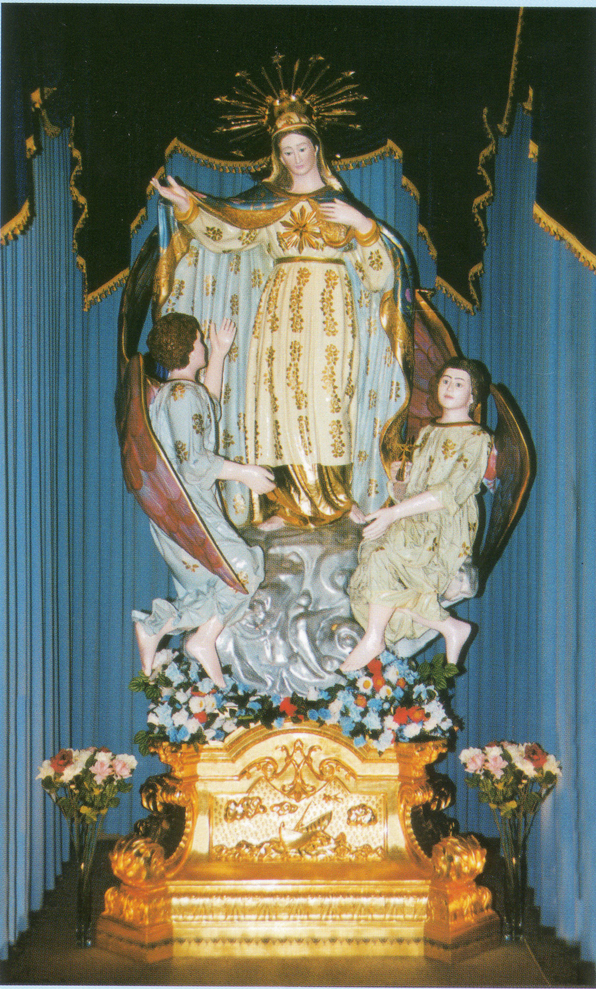
After Mass everyone is invited to join us for some refreshments.

SATURDAY 14 OCTOBER:
6.30pm: Feast Dinner Dance will be held at Emerald Receptions. DJ Domenic will be entertaining us on the night. Later on in the night the Maltese United Brass Band will join us to entertain us playing various joyous marches.

SUNDAY 15 OCTOBER:
2.30pm: High Mass: Celebrated by Parish Priest Canon Manuel Bonello assisted by Rev Fr Denis Carabott MSSP. The “Maltese Choir of Victoria” will participate during Mass. All Associations are invited to take part by joining us in the church celebrations as well as during the procession carrying their banners.
4.00pm: The procession with the beautiful Statue of Stella Maris will commence. The Maltese Own Band Philharmonic Society Inc and the Malta Gozo Concert Band will accompany the Statue around the streets of the Church.

6.00pm: After the procession everyone is welcome to come in the Hall where the two Maltese Bands will perform. Afterwards there will be DJ Domenic to entertain us.

THERE WILL BE FOOD AND DRINK FOR SALE. EVERYONE IS WELCOME.
THE COMMITTEE WISHES EVERYONE A GOOD TIME DURING THE FESTIVITIES.

SOLENNE CELEBRAZIONE ALLA VERGINE DEL S. ROSARIO DOMENICA 8 OTTOBRE
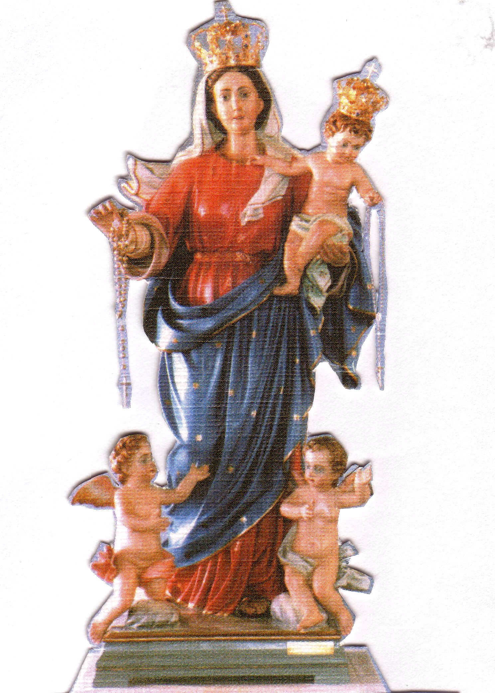
Nella nostra parrocchia di San Giuseppe Lavoratore
PROGRAMMA
Ore 2.00PM
Preghiere e Inni.
Processione con la statua
Recita del S. Rosario con i Misteri presentati dai bambini.
Ore 3.00PM Santa Messa concelebrata da Padre Luciano Toldo e Padre Emanuel Bonello,
Preghiera di affidamento alla Madonna.
Benedizione con il S.S.. Sacramento ai malati e famiglie.
Accompagnato dal coro di Holy Name con musicista Padre Raffaele Rossi.

THANKSGIVING ENVELOPES
The current series of Thanksgiving envelopes end this weekend.
A new series of Thanksgiving envelopes have been issued for the following six months and will be delivered to your homes within the next week.
We ask parishioners who are not currently listed through Thanksgiving to please consider supporting the parish in this way. Please contact the Parish Office for further details on 9460 3013.
We invite those parishioners who distribute the Thanksgiving envelopes to please collect your allocated streets from the sacristy. The distributors are as follows: B Nadenbousch, P Sparano, J Barbaro, S Ciantar, J Kearney, R Di Guglielmo, T Sinopoli, D Cipollone, R Catena, P Caligiuri, P Leggiero, A Filippone, & V Zele.

